**Effecta DOA**

Contents

What is Effecta DOA?

Prerequisite

Browser version & settings.

Script generation

Script execution.

**Effecta DOA**

Effecta day one automation (DOA) feature allows manual tester to write scripts quickly without learning or knowing any kind of scripting languages. DOA gives a common platform for scripting, maintenance and execution.

For script generation and execution Effecta DOA uses local machine. For that we need to maintain directory structure before generating and executing scripts.

**Prerequisites:-**

Java needs to install on the local machine.

Both JDK & JRE needs to be install on the local machine.

**Java version: 1.8.0** (64 bit) or below.

* After installing java on local machine .we have to check whether our local machine is having java installed or not by typing bellow command in cmd.

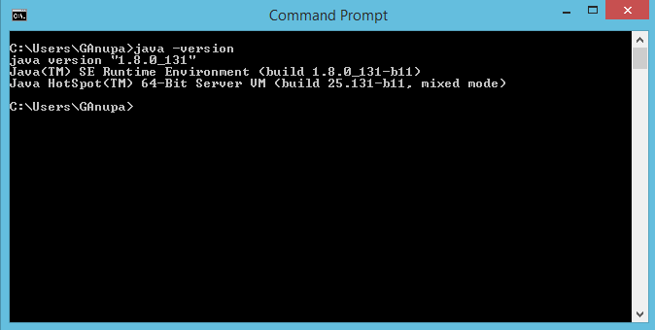

* Next step is to check whetherpath is configured or not.
* Execute the command “javac” in command prompt.
* If prompt get throws a message javac is not recognized as internal or external command that means JDK path is not set.

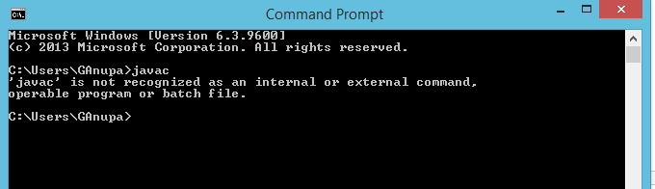

**Environment configuration (path configuration):**

**Steps:**

1. Open control panel and select system and security

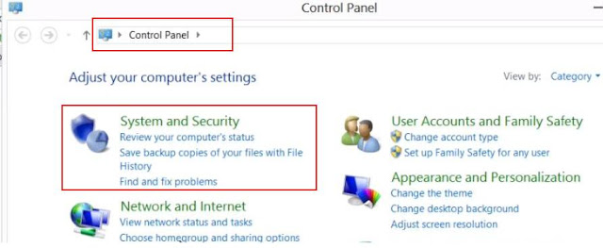

1. Select system

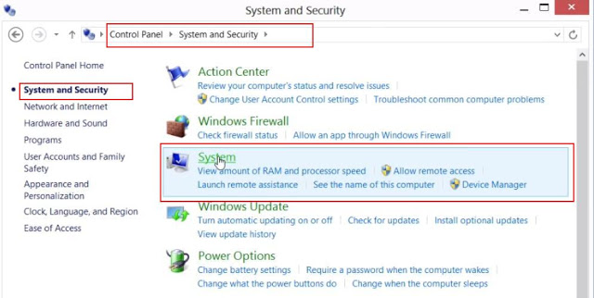

3. Select advanced system setting. It ask for administration permission.

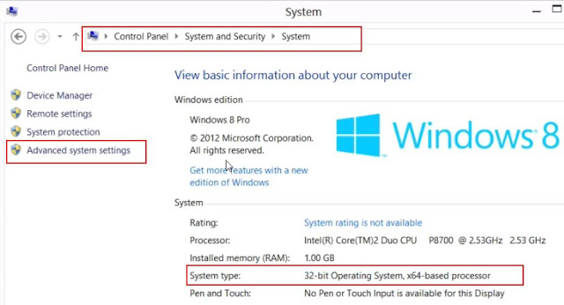

Select environment variables

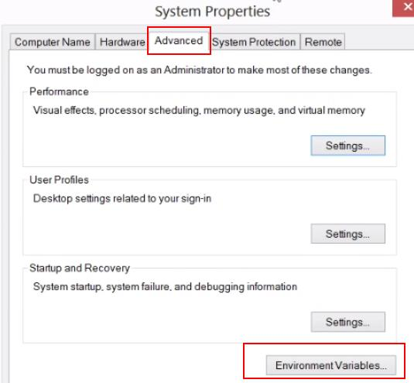

Select and edit path environment.

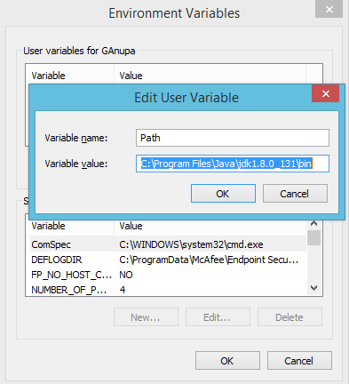

**Ex: c:\program files\java\JDK1.8.0_131\bin**

6. Verify path by typing javac in command prompt

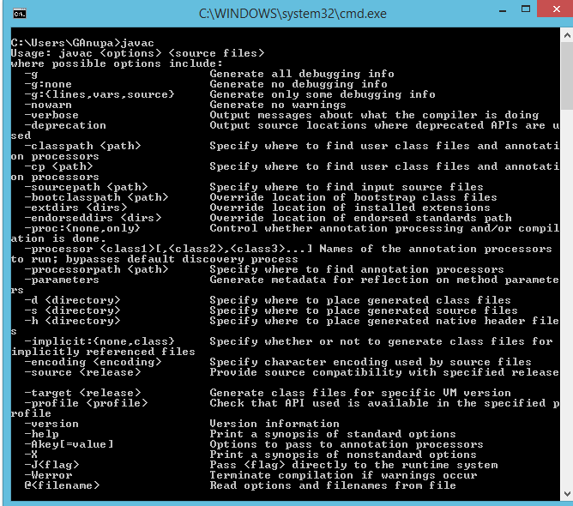

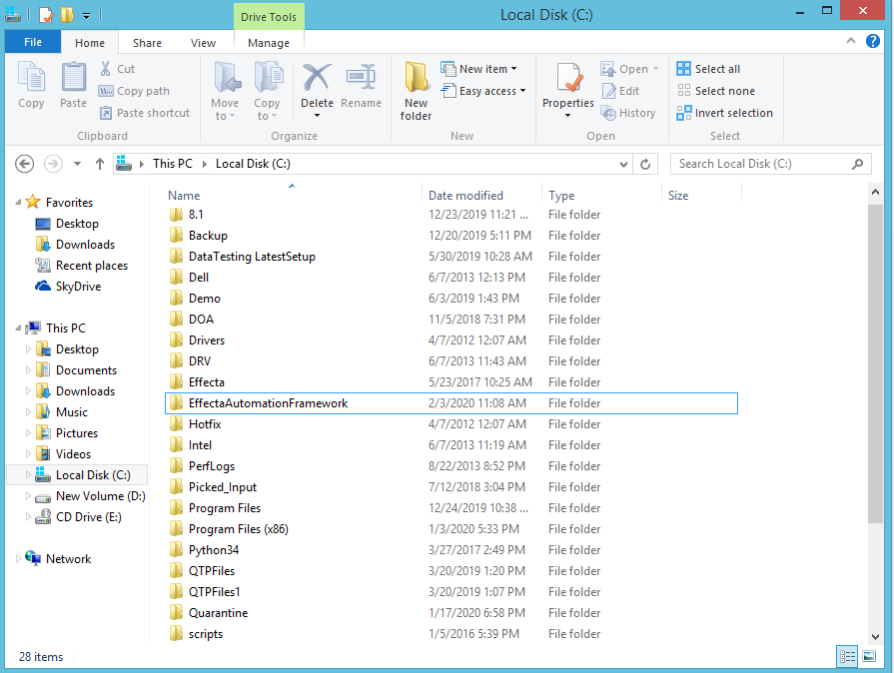

**C:\EffectaAutomationFramework**

For Selenium projects we have to create a folder (Selenium) in root directory.

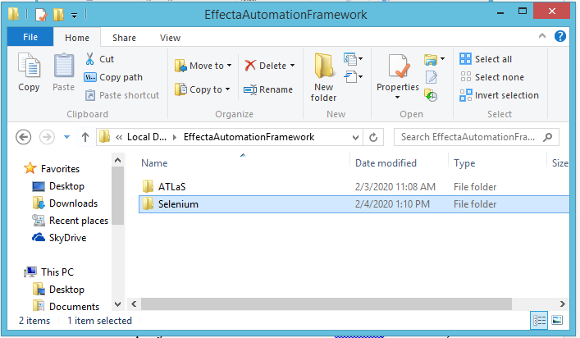**c:\EffectaAutomationFramework\Selenium**

Under Selenium we can see the following folders **(use third party reference)**

**Prolifics**

**data folder.**

**Resources.**

**Results.**

**Xml_files.**

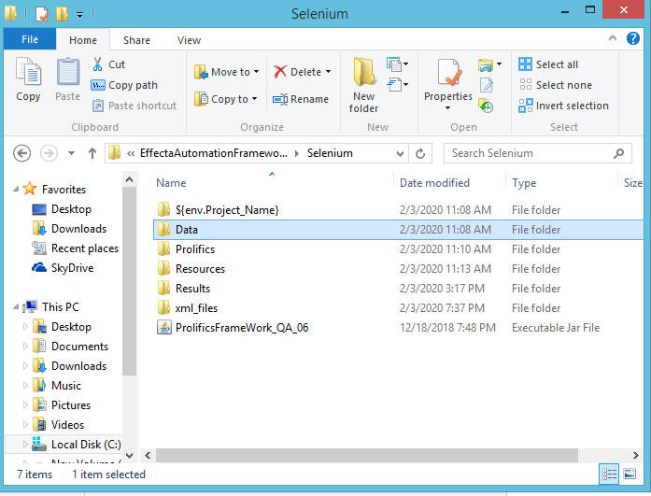

**In prolifics folder:**

We should have following folders.

**(example: the prolifics folder should have the following folder)**

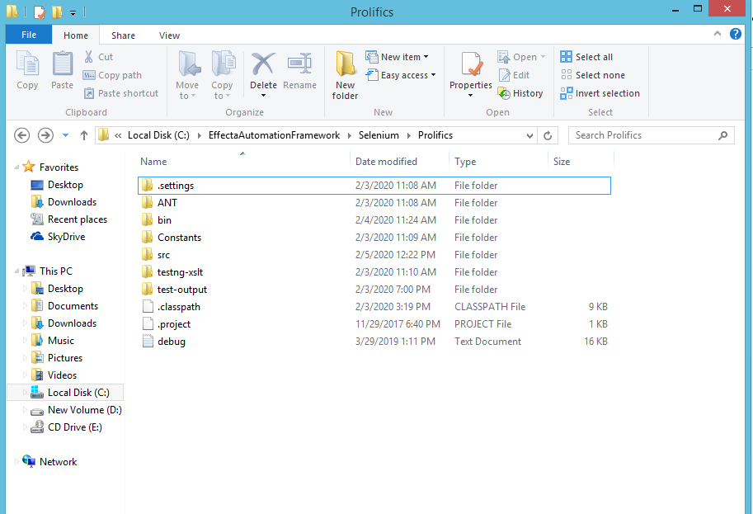

**Ant folder**:

Where we need to keep apache-ant-1.9.3.

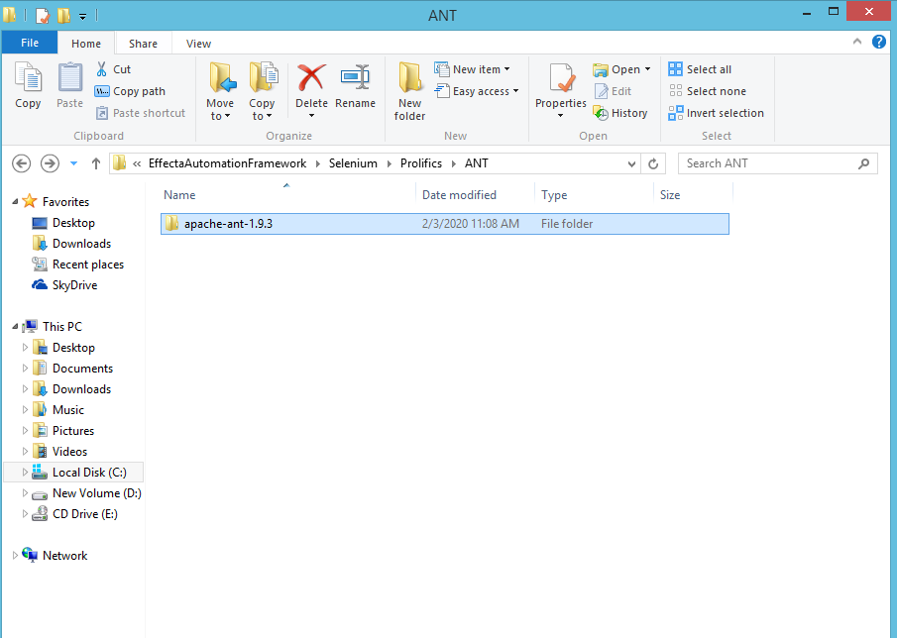

**In bin folder:**

Under **bin** folder create two folders one is **pom** and another one is **scripts**. When we execute the test cases here the pom files get compiled and stored in this bin/pom.

Main file gets compiled and stored in bin/scripts.

For executing and running scripts we need some batch files and jar files that has to be placed in resources folder.

**Ex: \EffectaAutomationFramework\Selenium\resources**

**In src folder:**

**C:\EffectaAutomationFramework\Selenium\prolifics\src**

**Pom** (this folder is used to store generated page object model).

**Scripts** (this folder is used to store generated main script).

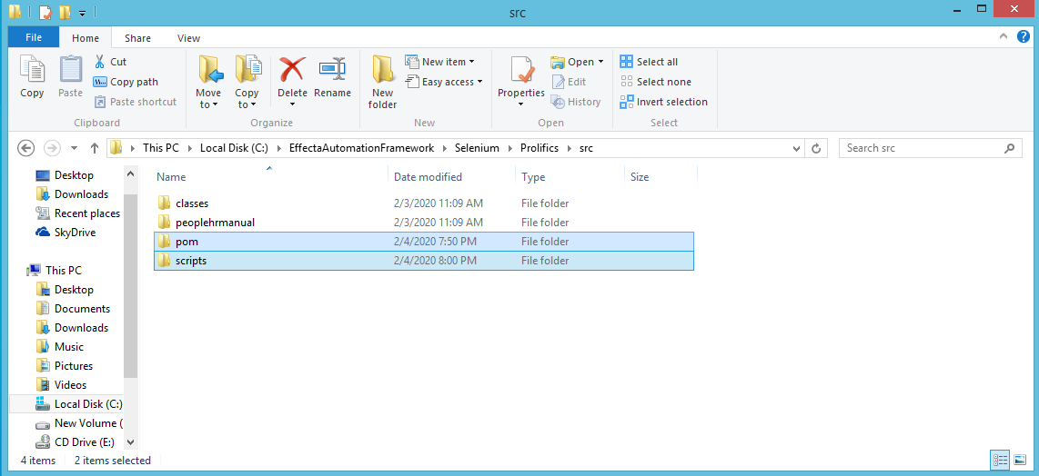  
  
**In pom:**

* When we run test scripts with application name folder will be created.

**In scripts folder:**

* Here main script will be generated with

Ex:-testcasename.java

**In resource folder:**

* We need to maintain all the batch and jar files.
* Following are the below jar and batch files for this files please ask the shared path or contact testing team.

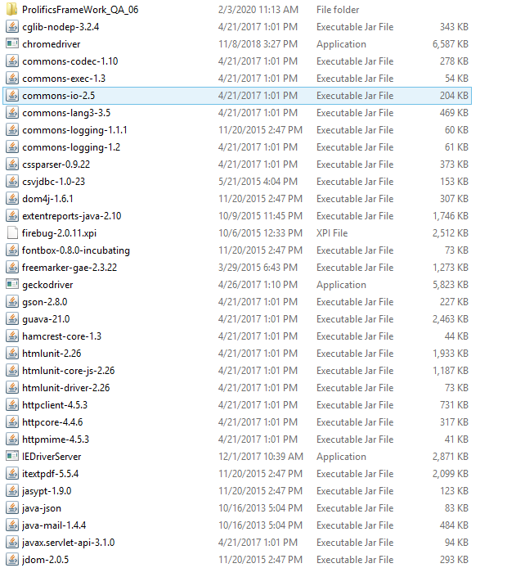

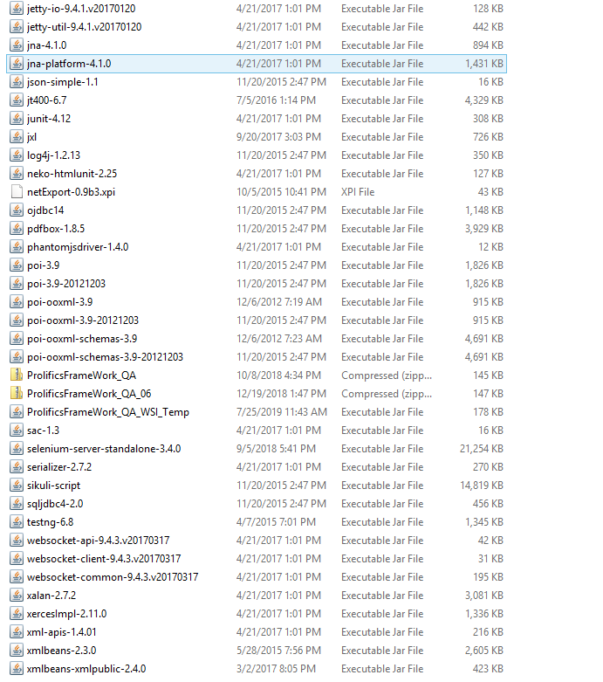

**Folder structure as follows:-**

**Creating root directory:**

In c drive create a directory EffectaAutomationFramework

|  |
| --- |
| **Script generation**  **root script directory**  **c:\EffectaAutomationFramework\**  **for Selenium script generation:**  **c:\EffectaAutomationFramework\Selenium\prolifics**  **pom files location (java file):**  **c:\EffectaAutomationFramework\Selenium\prolifics\src\pom**  **main script location:**  **c:\EffectaAutomationFramework\Selenium\prolifics\src\scripts**  **Script execution paths:**  **compiled pom file location:**  **c:\EffectaAutomationFramework\Selenium\prolifics\bin\pom.**  **compiled main script location:**  **c:\EffectaAutomationFramework\Selenium\prolifics\bin\scripts\** |

**Browser version:**

For script generation and execution. Effecta uses WPF component. In order to run and execute the scripts, browser need to support the WPF component and we need to provide browser privacy access.

Following are the browser version that is supported by the various browsers**:**

Internet explorer version: i.e. 11.0 or bellow.

Google chrome version: 79.0 or bellow (64bit).

**Privacy setting in internet explorer.**

Open internet explorer & choose internet options then a popup displays

Click on privacy

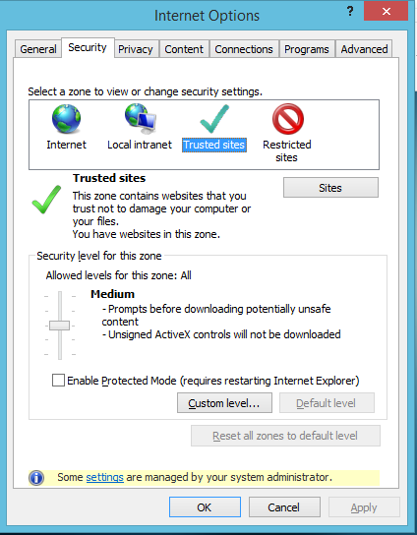

Click on sites.

Below pop up appears and enter url in the address bar and click on allow and click on.

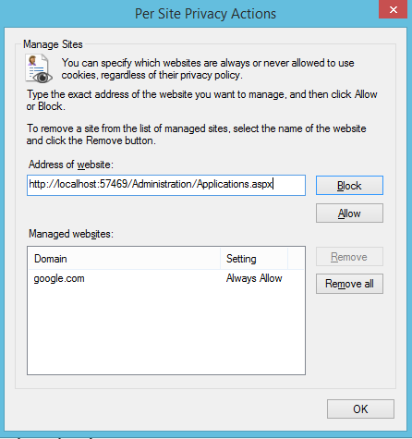

**Test run:**

* Login into Effecta by providing valid credentials.
* Email id, password and appropriate instance.

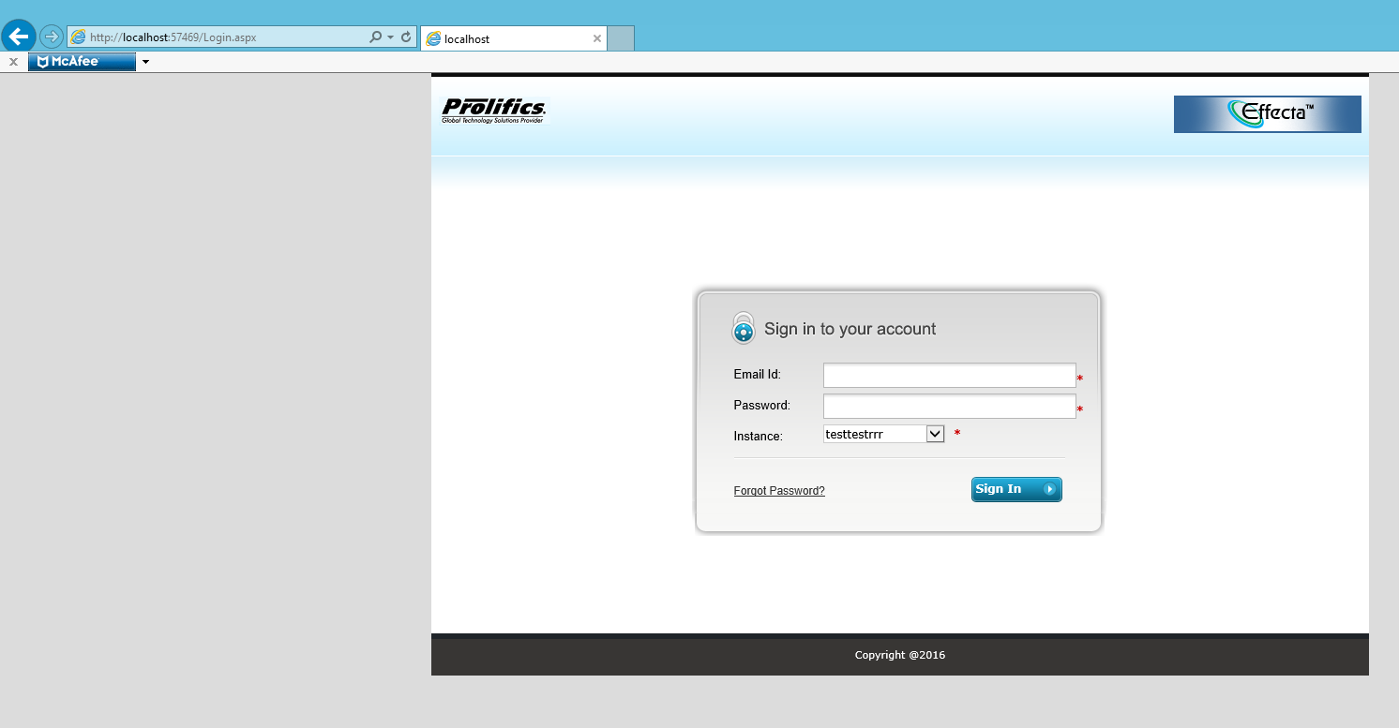

**Creating an application:**

* Under administration click on application then bellow grid appears.

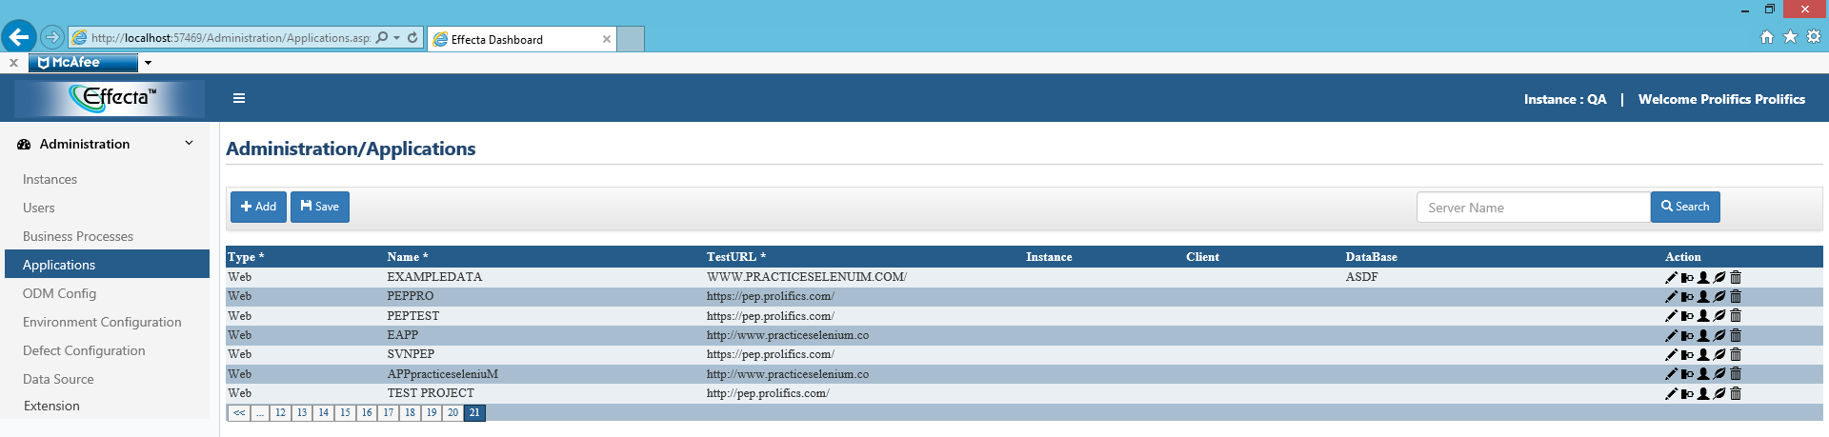

* Then next click on **add** and give necessary parameters (type, name, URL).

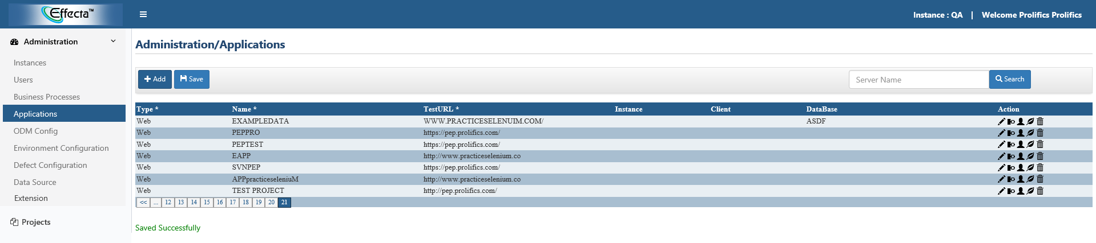

**Creating test script:**

* For creating a test script click on **test script.**

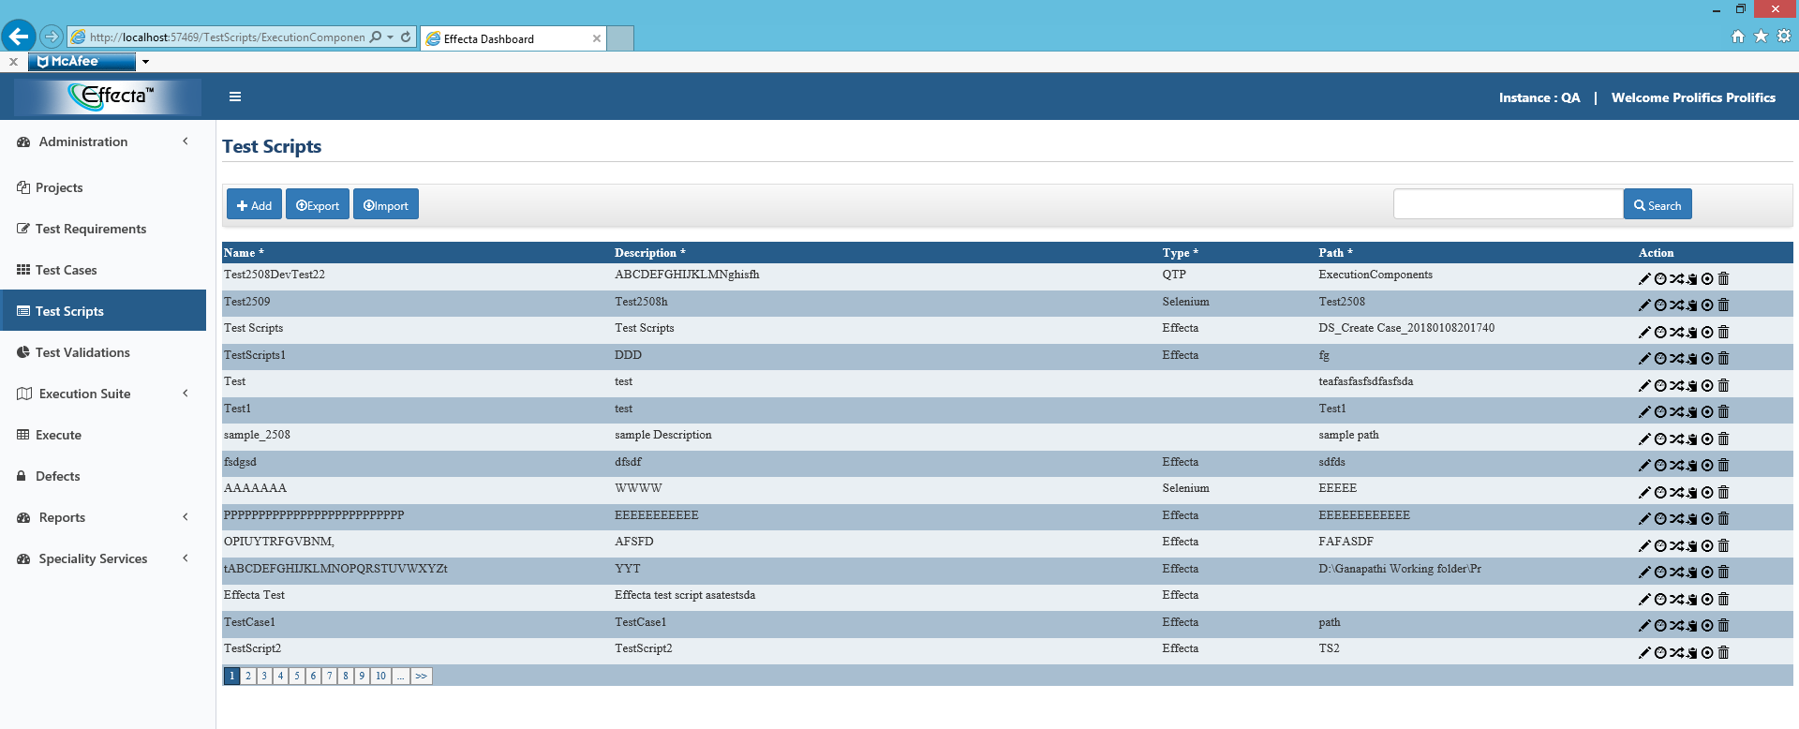

* Click on **add.**
* A modal popup displays to enter all the test script details.

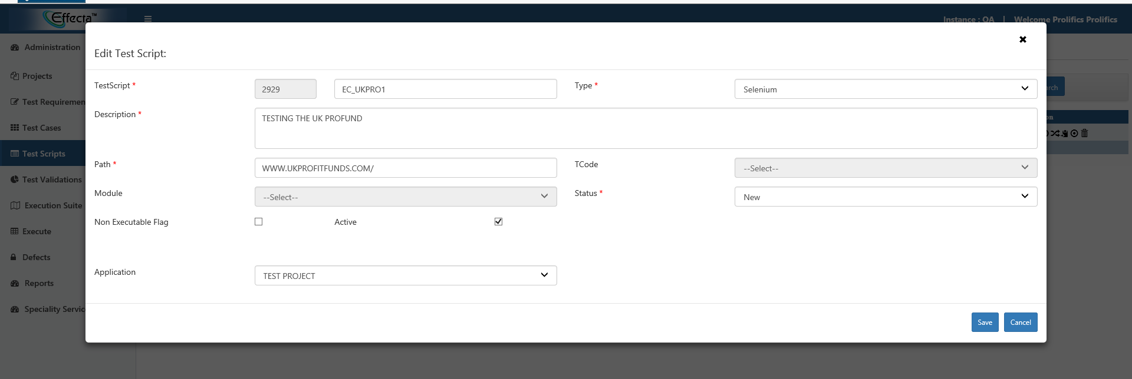

* Give valid test script name.
* Select type either it is Selenium or QTP or Effecta.
* Give valid description, path and other mandatory.
* Select the application which we have created in the application module.
* Click on save.

Then save successfully appears as below.

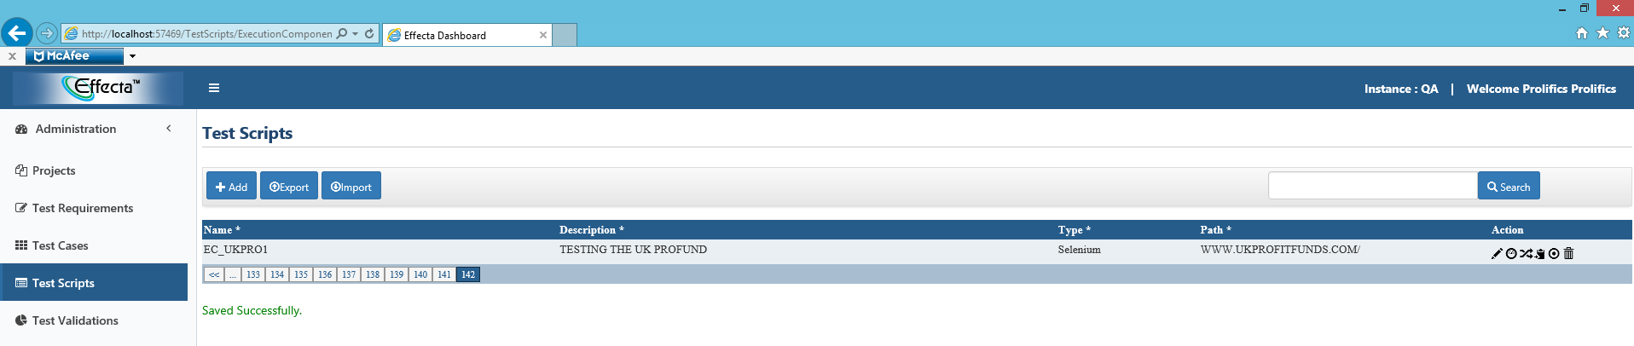

**Automating test script:-**

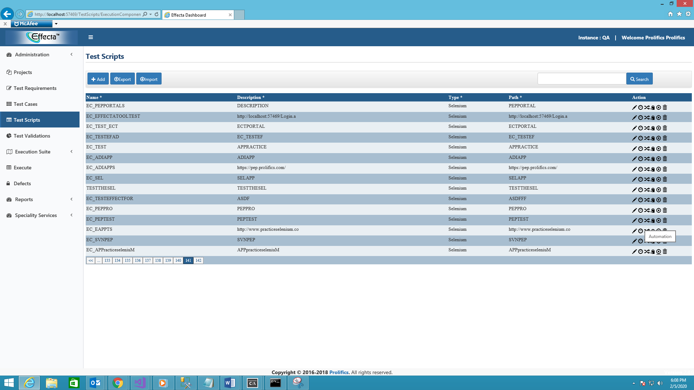

* Click on automation button as shown in the above picture.
* It loads the WPF component as bellow for this we need to ensure all the settings are properly configured or not.

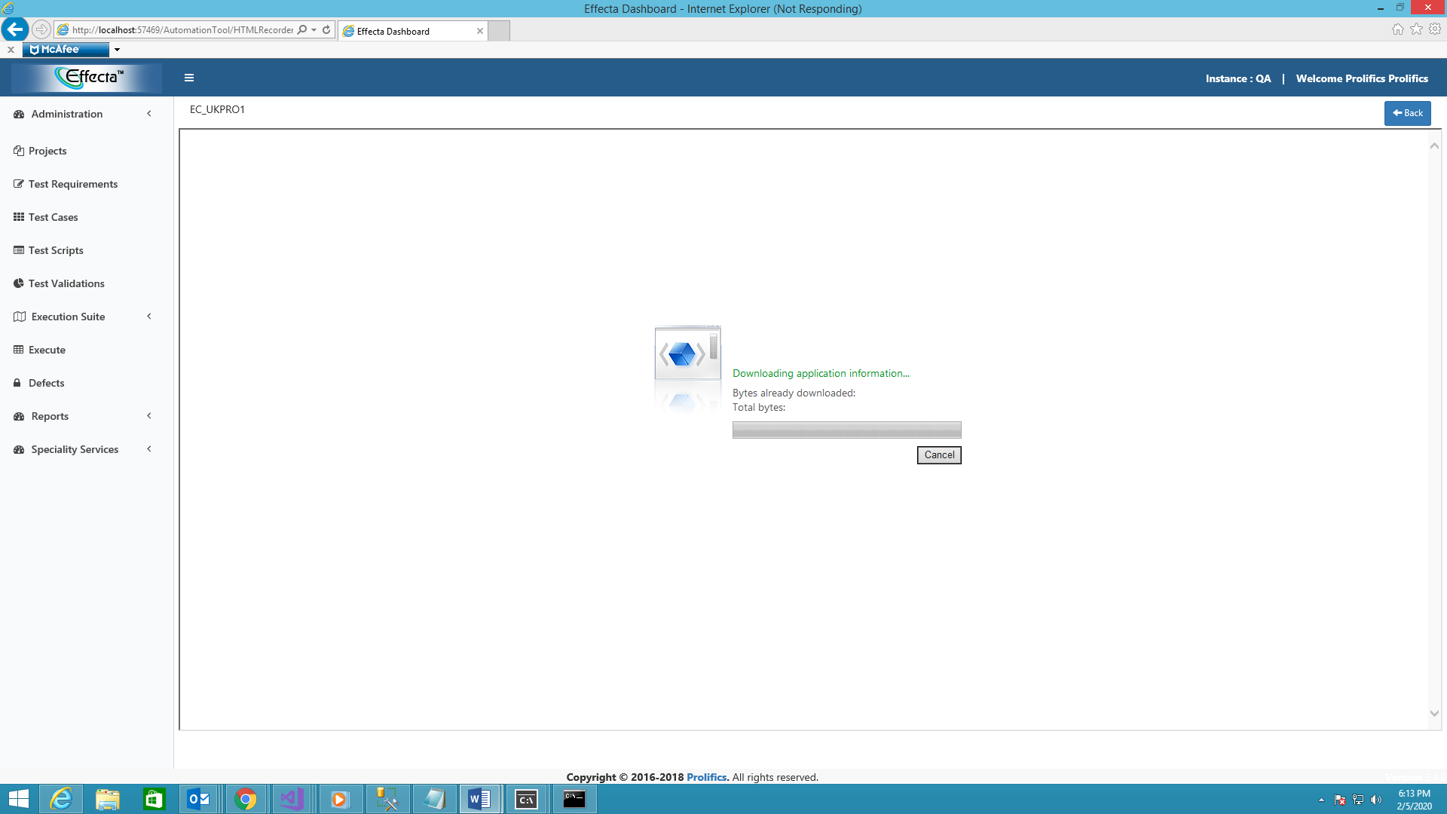

* Click on **record script**.

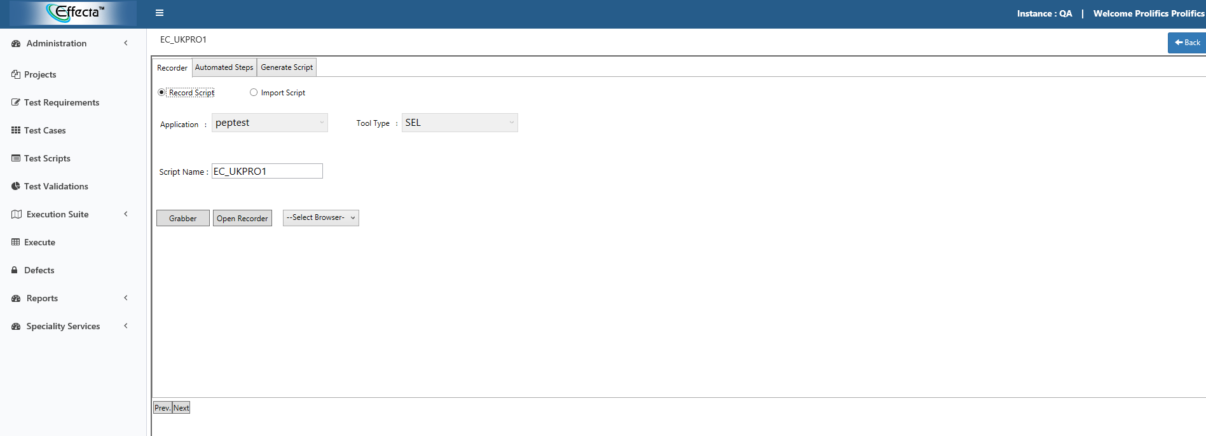

* Then it displays all the test script details such as test script name, application name.
* Now click on **grabber.**

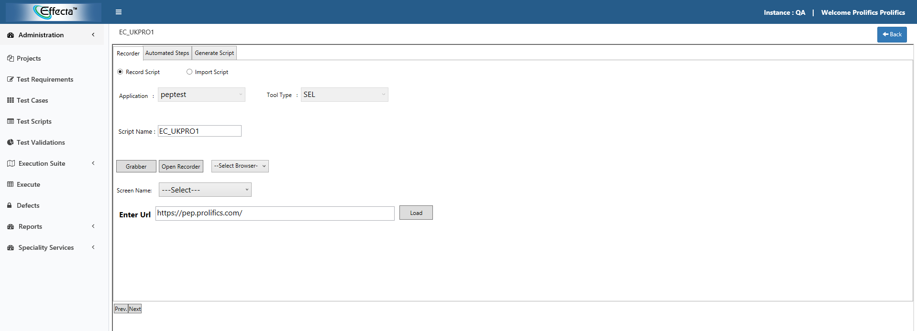

* When we click on grabber it displays the URL of the application.
* Select screen as others.
* Click on load:-
* It loads the application in the WPF component.
* Click on capture to capture all the web elements of the screen.

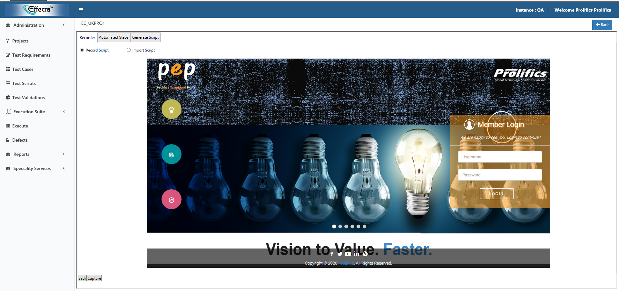

* When we click on capture it grabs all the elements on the screen.

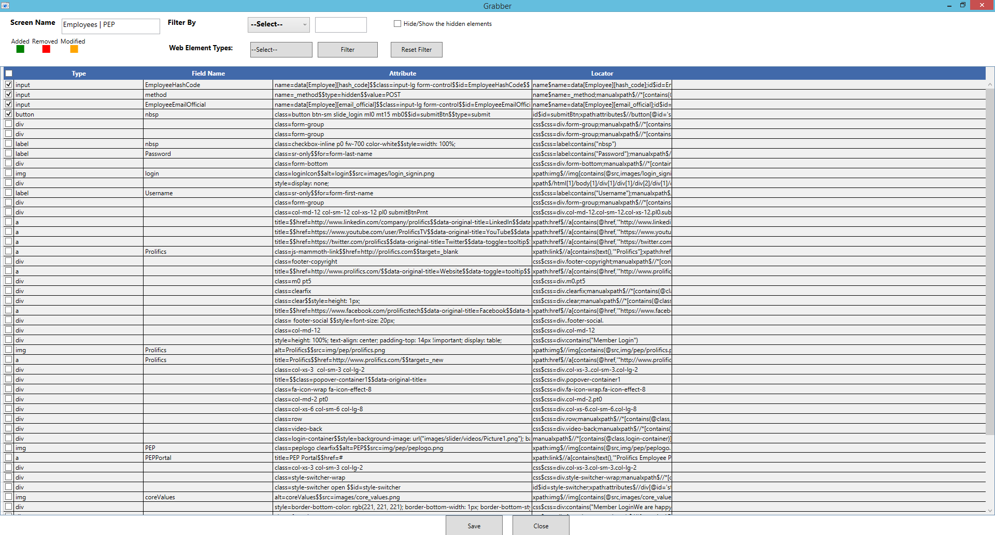

* Click on save.
* A popup appears as below

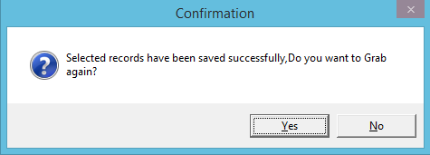

* If you want to grab again click on **Yes** or click **No.**

**Recording script.**

* Click on open recorder.
* Application will be opened on the selected browser.

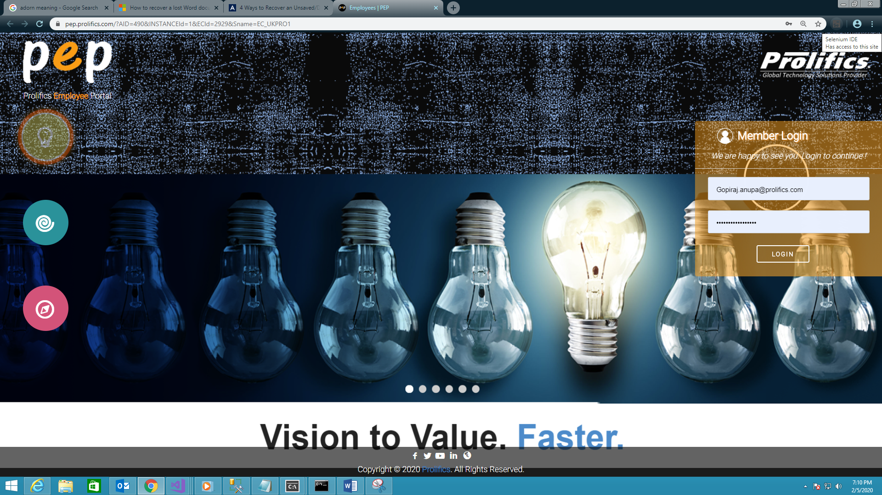

Click on Selenium ide and start recording the steps .after recording save the file with the JSON as extension.

**Importing the script.**

* Click on import script.
* Browse the appropriate file.

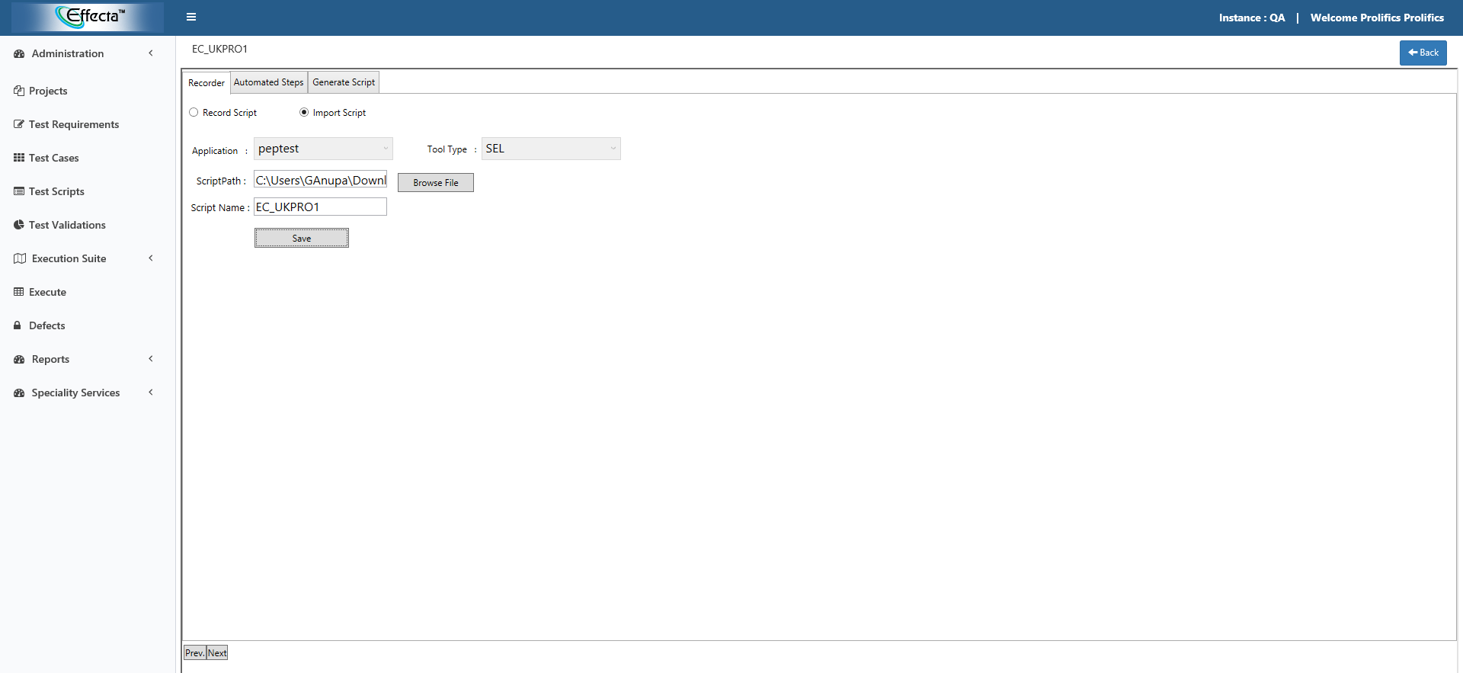

* Click on **save**.
* A popup appears with a message record saved successfully.

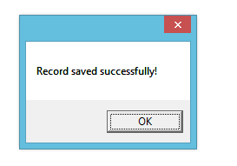

Click on **next**, it displays screen it includes grabbed locators, locators, data.

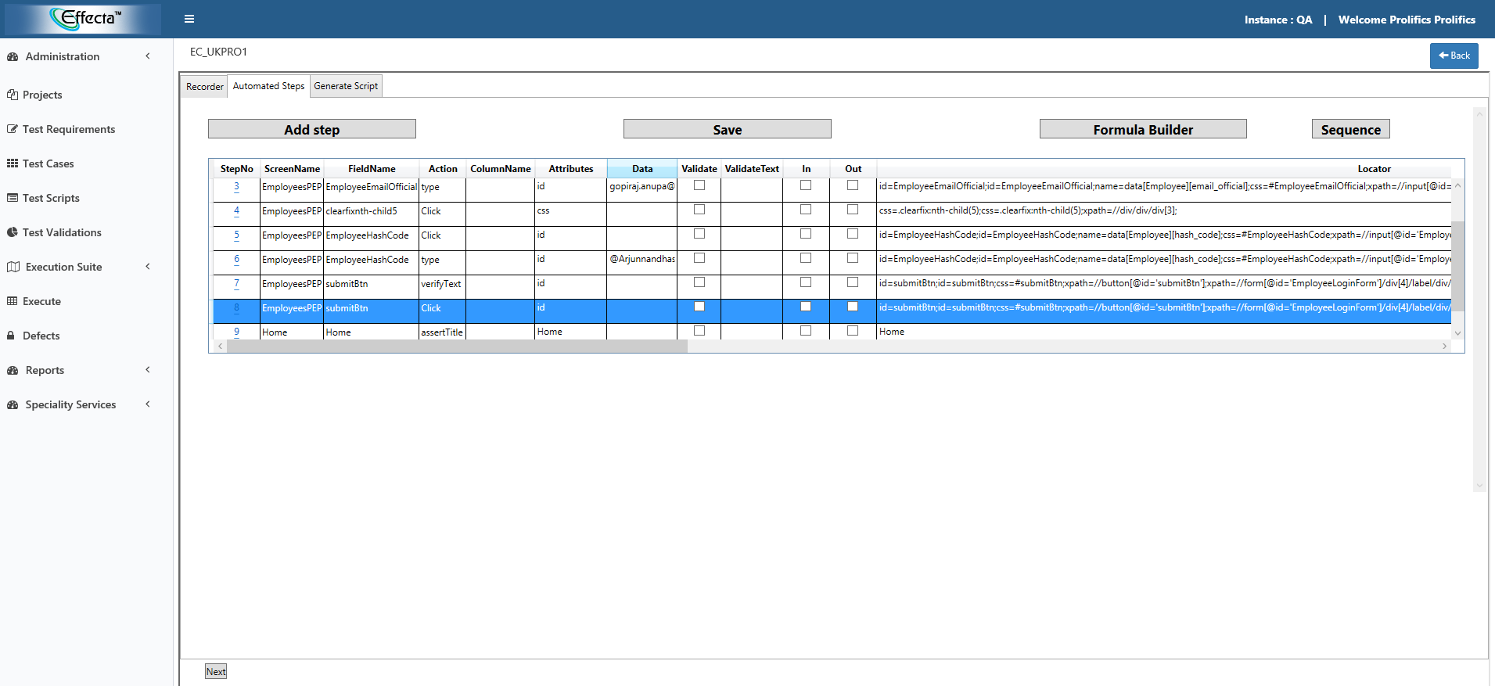

* Click **next**.
* Click on **generate script**.

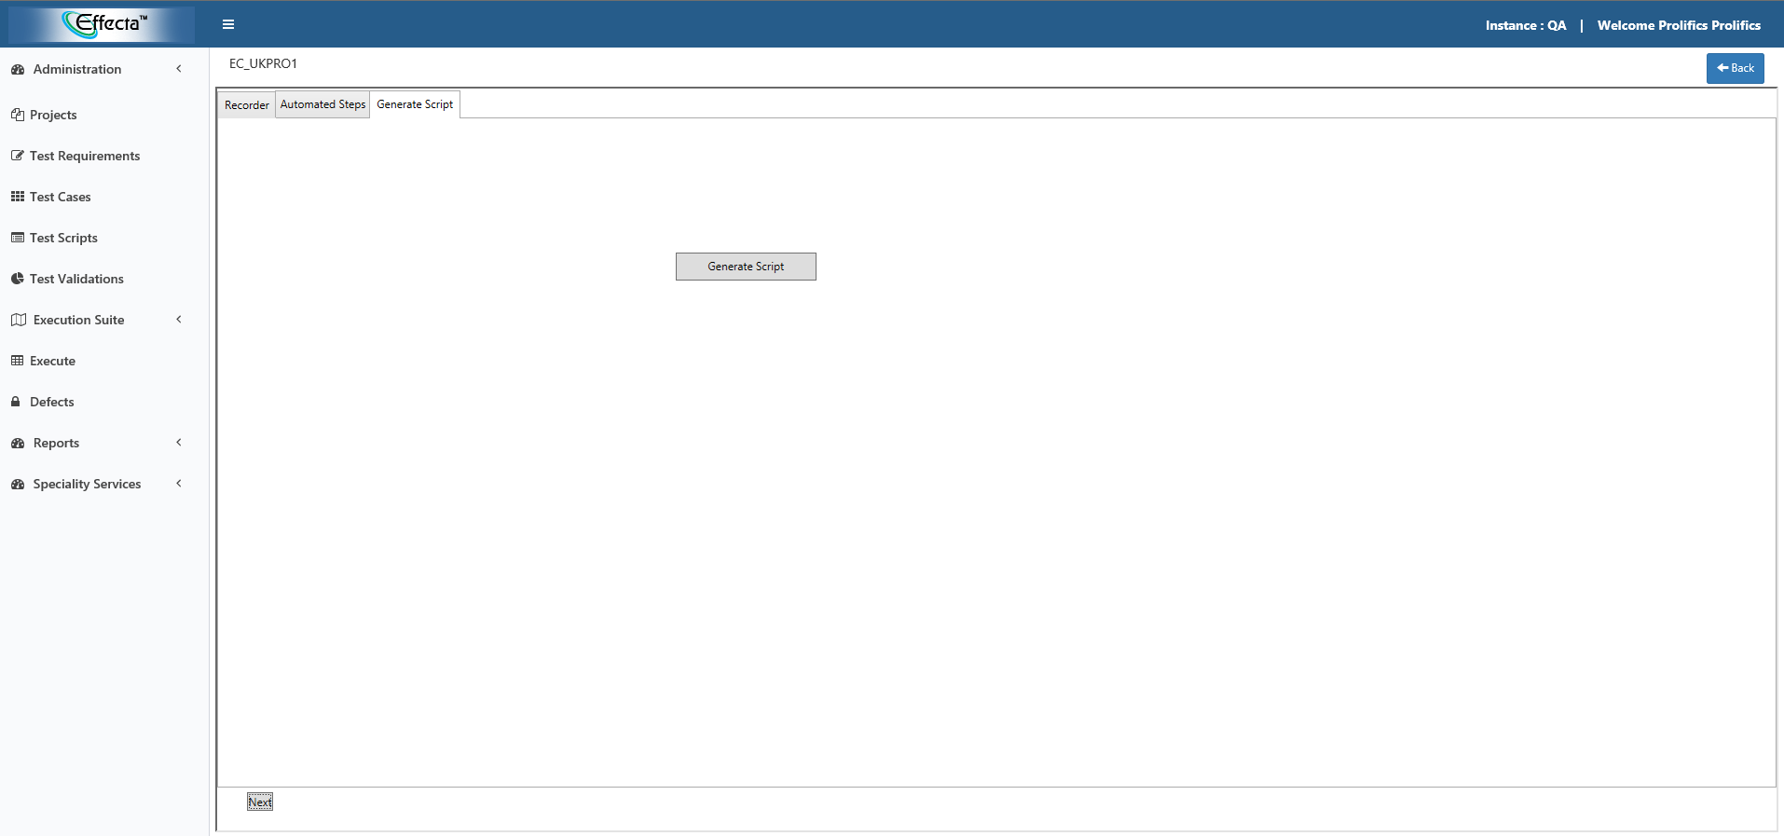

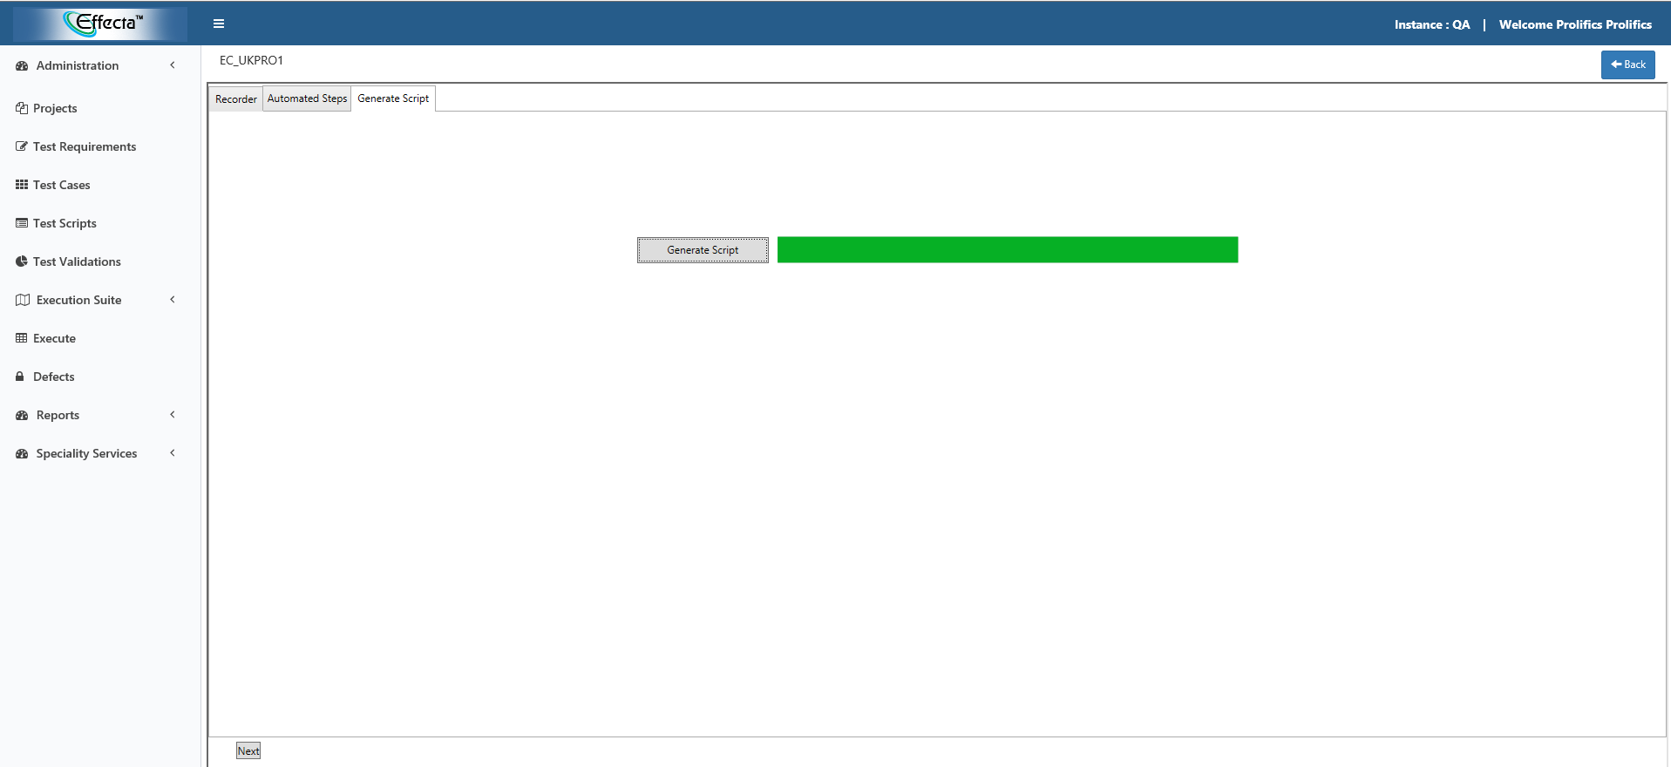

After generating the script it displays a popup operation completed.

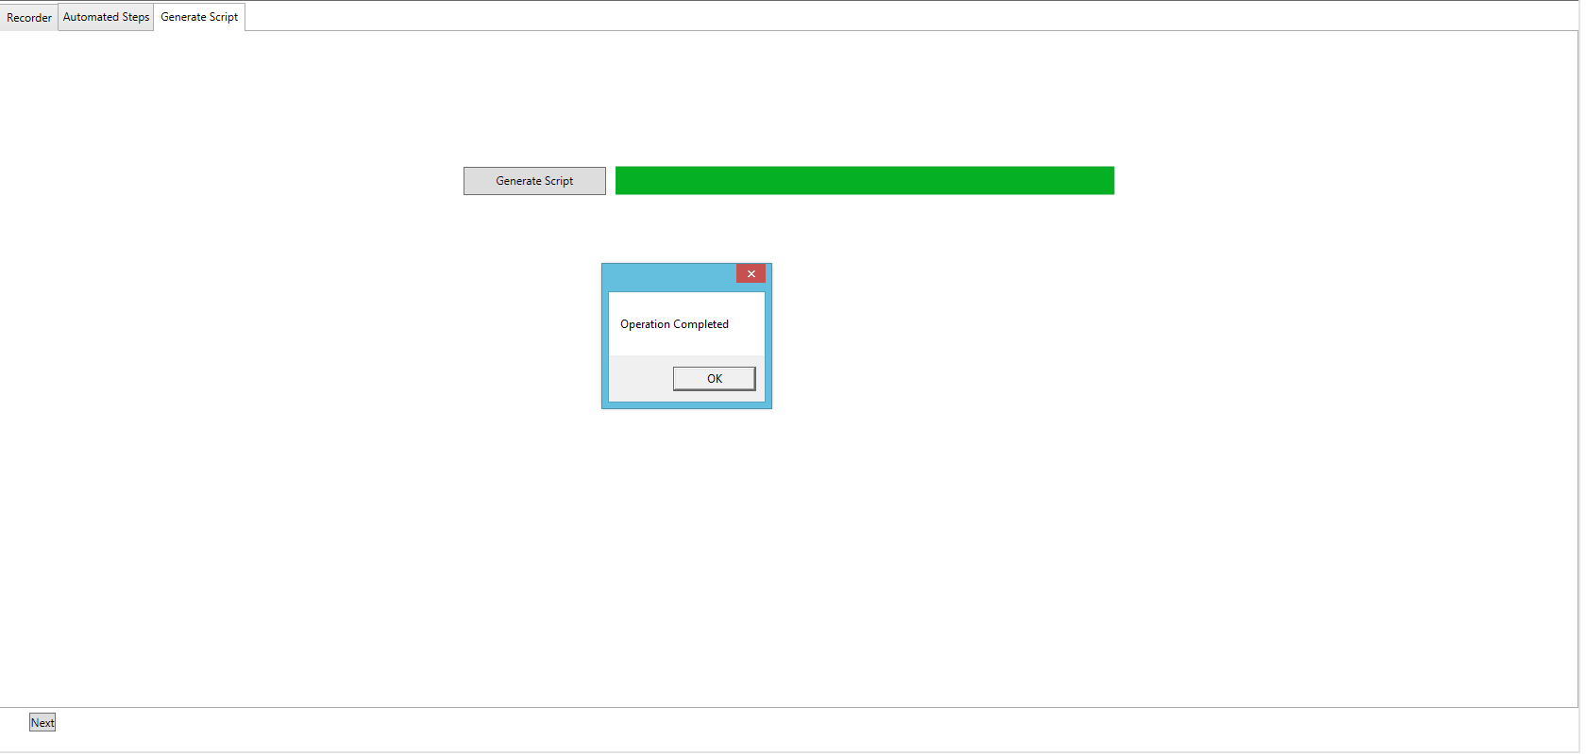

* When we click on generate script pom file gets generated.
* Each recorded screen will be one pom file that will be stored under.

C:\EffectaAutomationFramework\Selenium\prolifics\src\pom

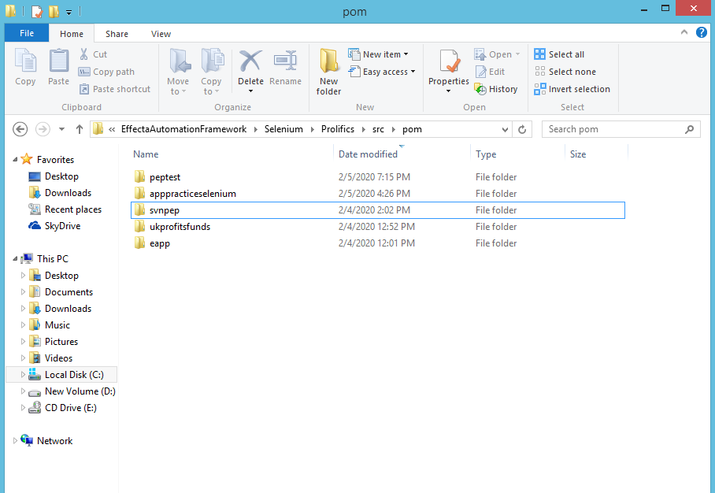

* Pom file get generated under src folder which named same as application name.
* There we can find the pom files as below.

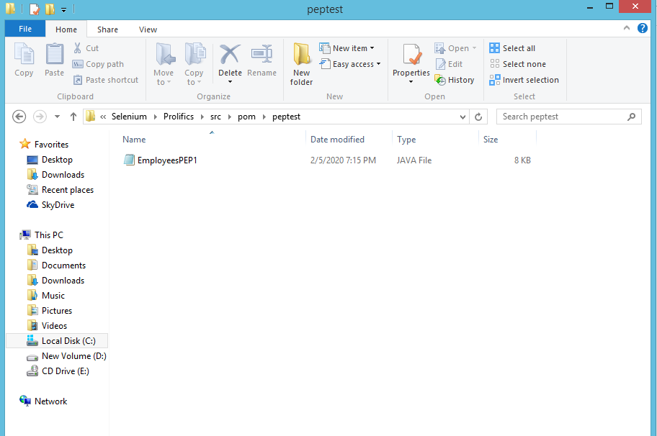

**Test run:-**

* Now we need to create a test case and map the test script to the test case.
* For creating test case click on test case.

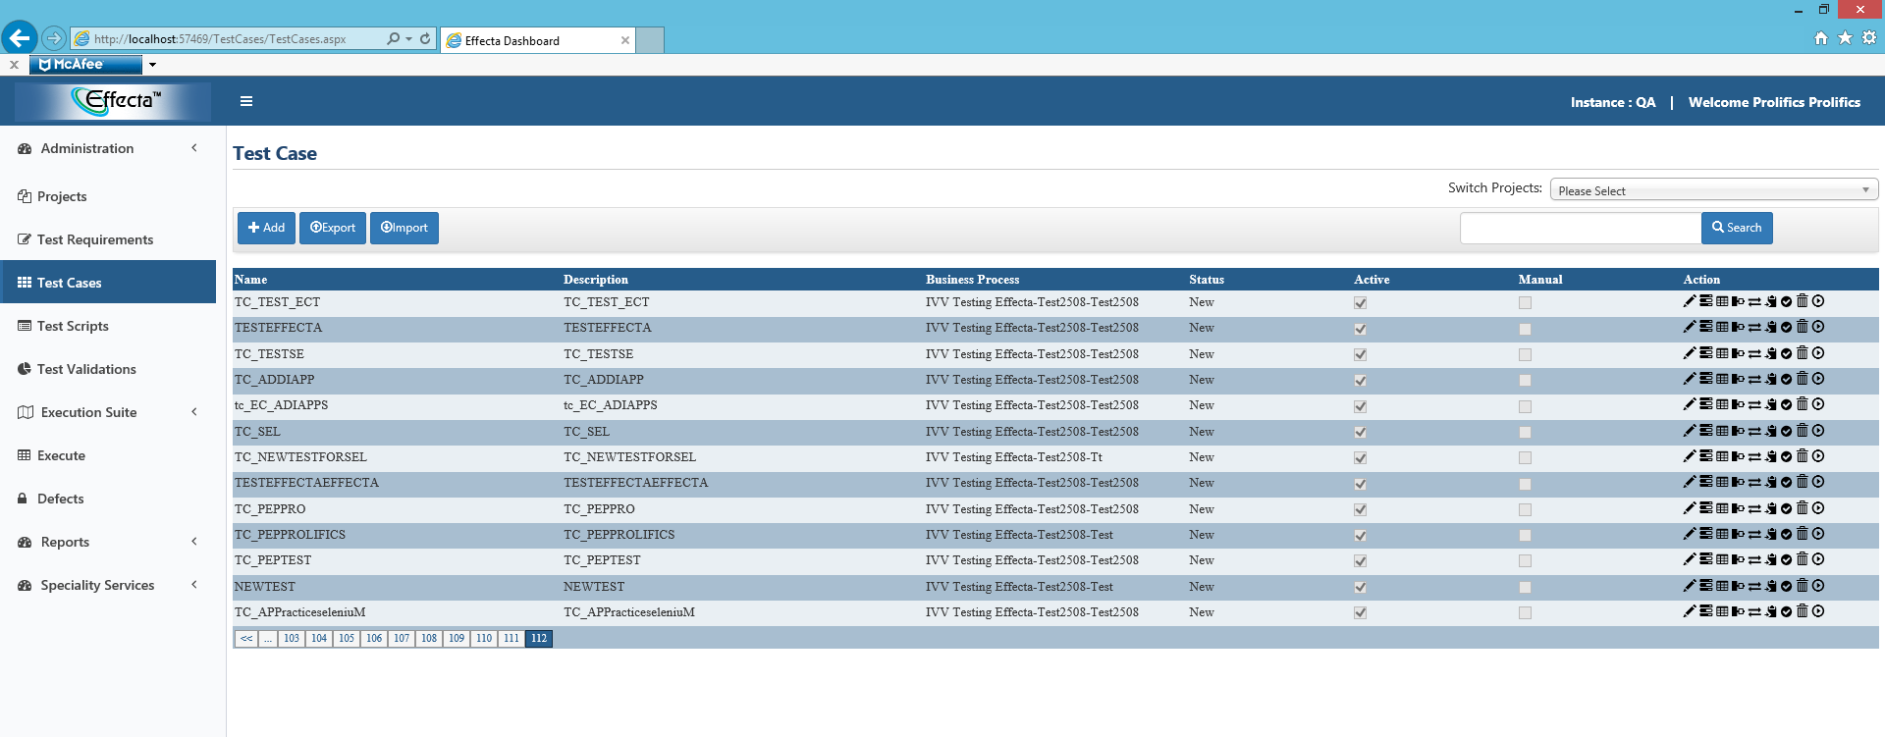

* Click on **ADD**. Then it redirects to the test cases page as below.

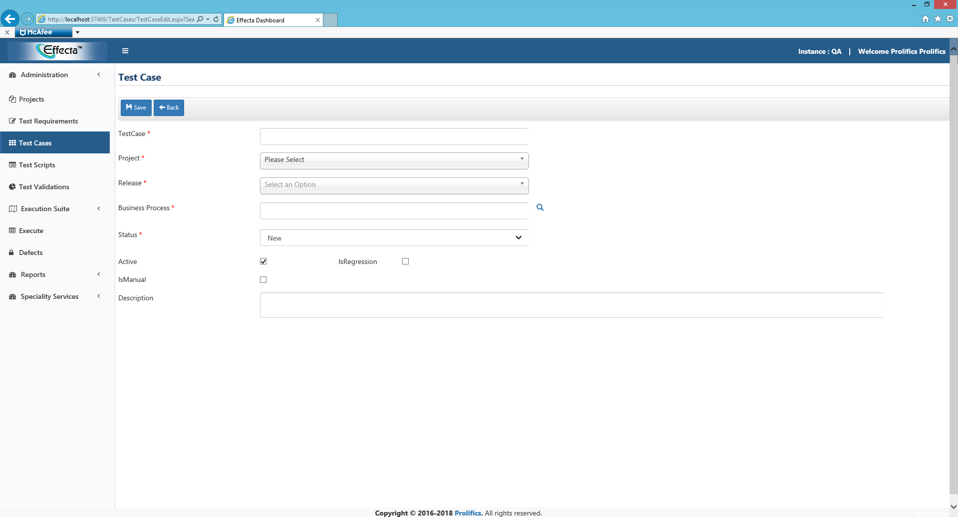

* Give valid test case name.
* Select project, release, business process select status give description and click on save.
* Now test case will be created.

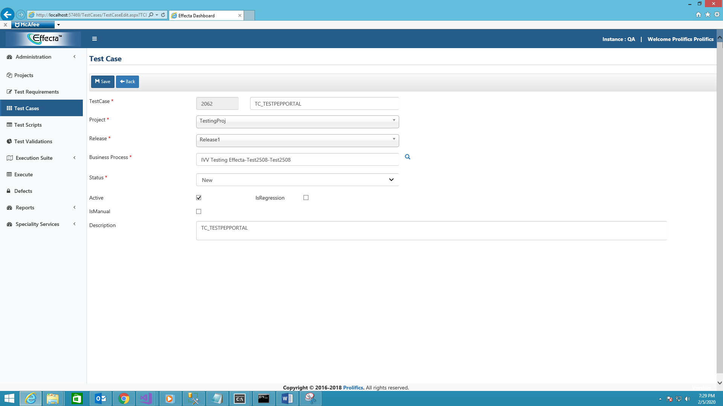

* It displays a message saved successfully.

**Design steps:**

* Click on **design steps.**

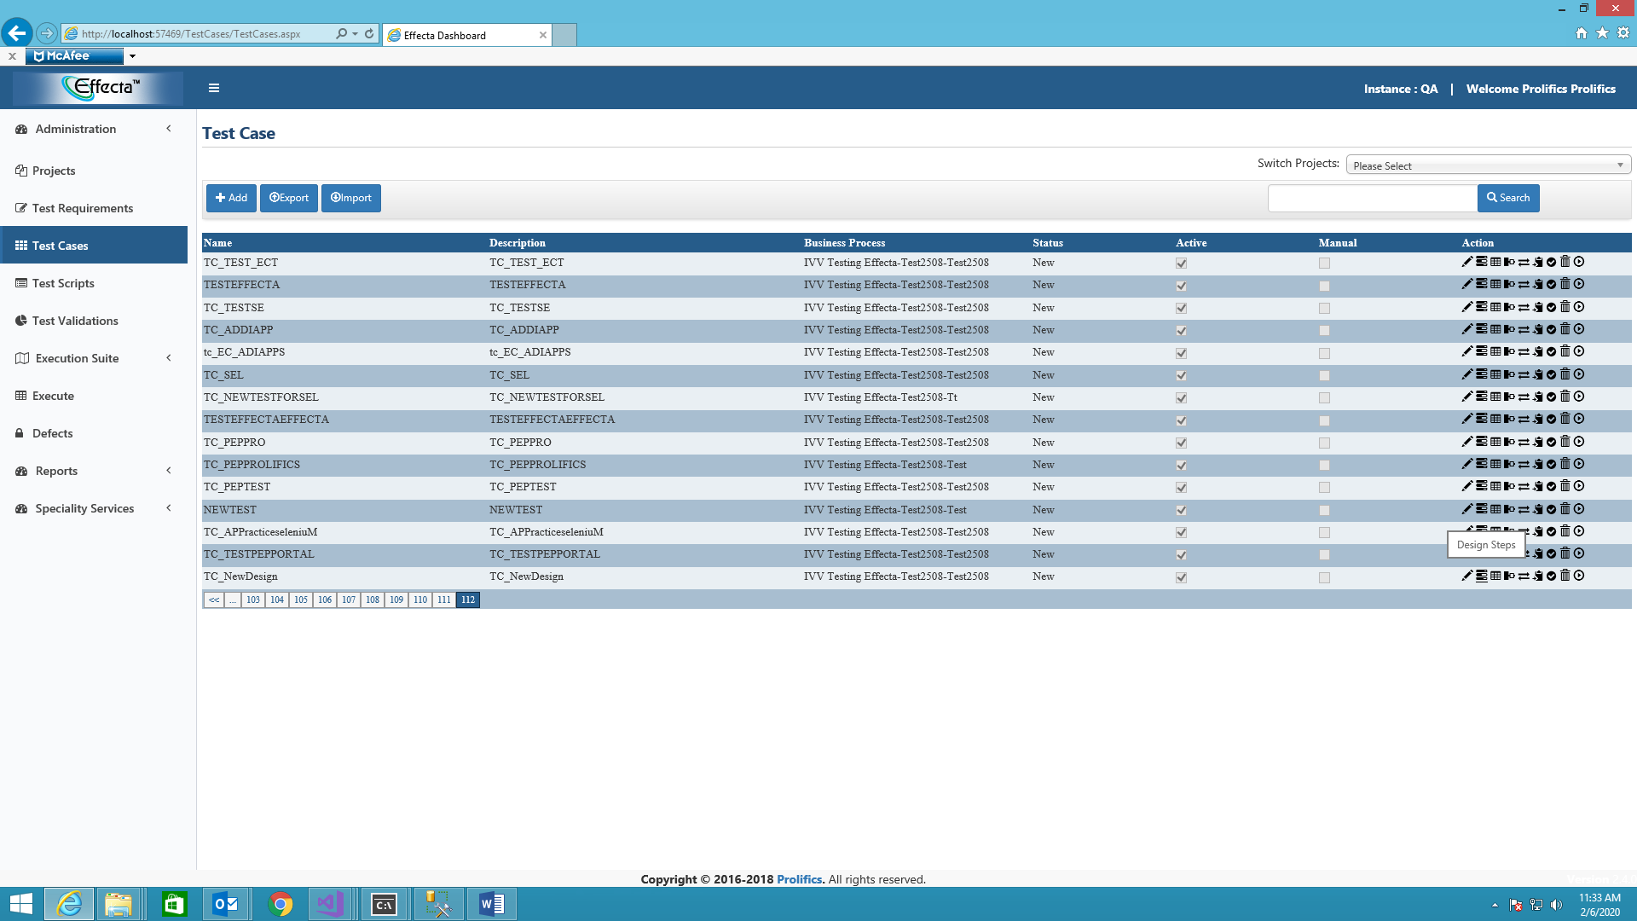

* Then it redirect to the page as below.

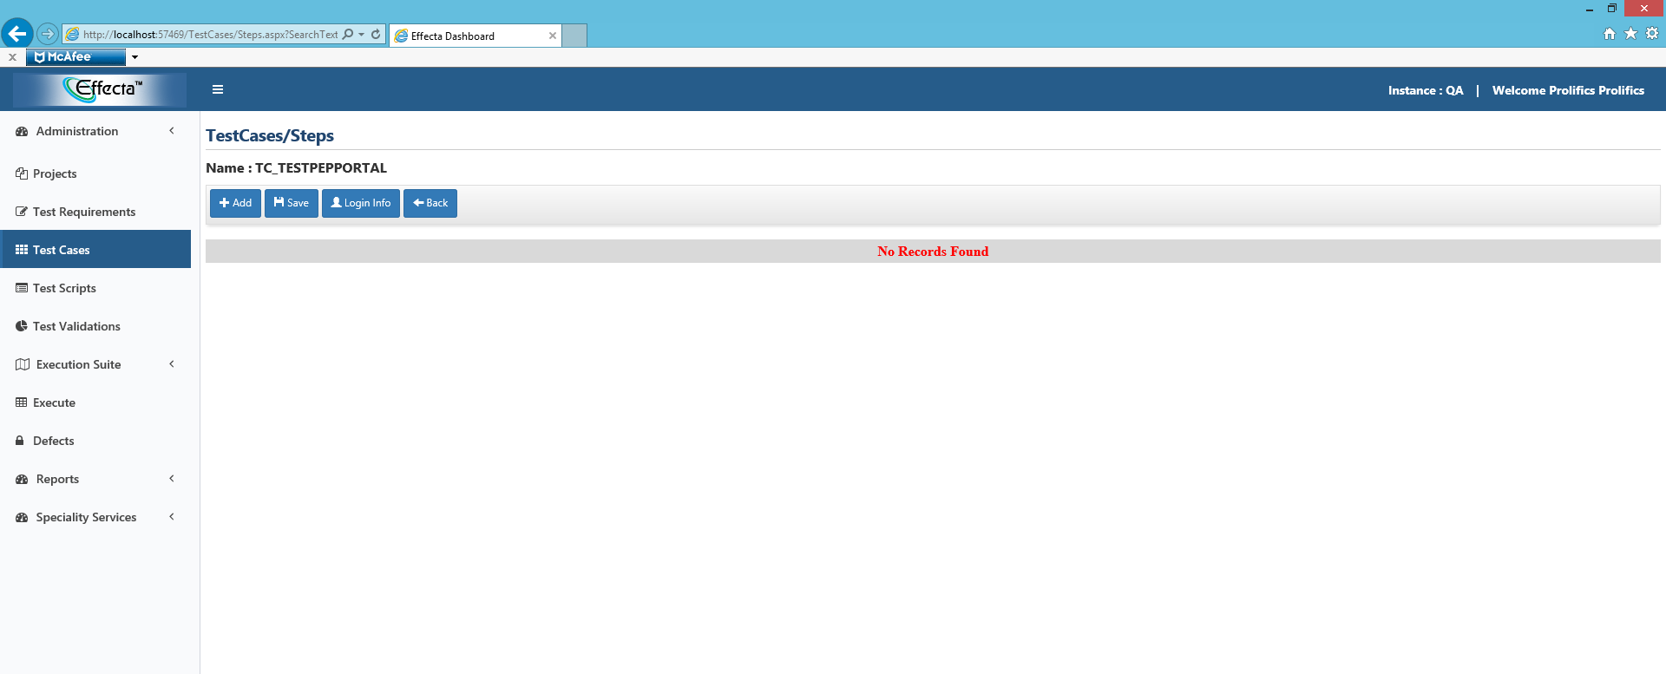

* Click on add button.it displays a popup

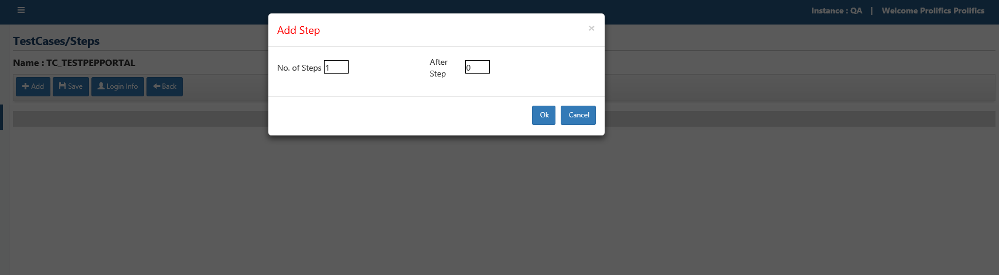

* Add the steps required.
* Give description and click on map test scripts.

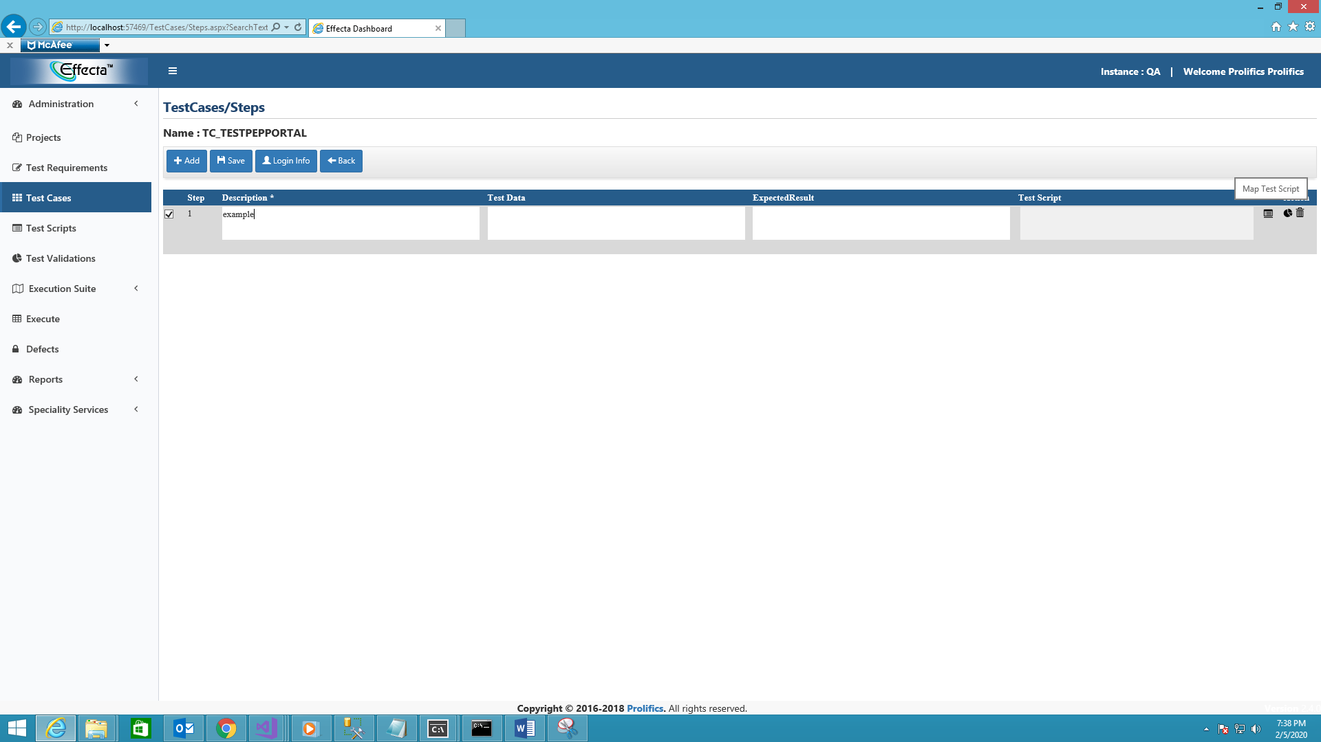

* Select the test scripts that required.

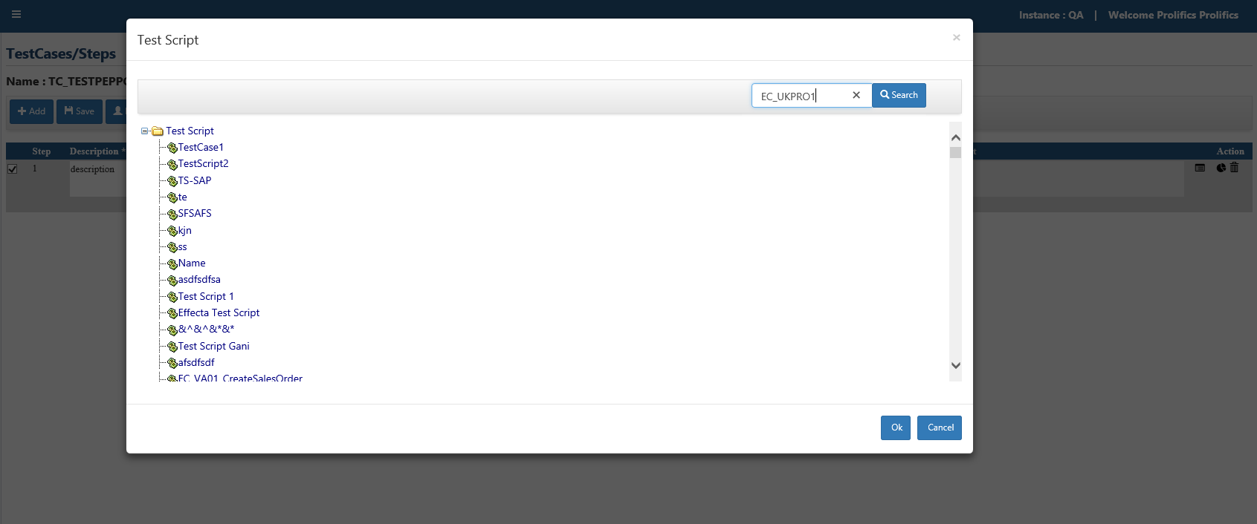

* Click on ok and save the design step.it shows saved successfully.

**Creating dataset.**

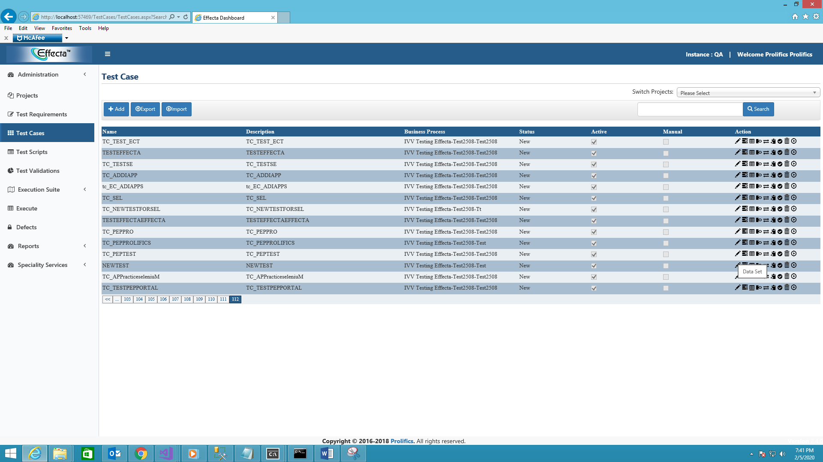

* Click on dataset.
* Create data set it redirects to dataset page click on add and give description of data set click on save.

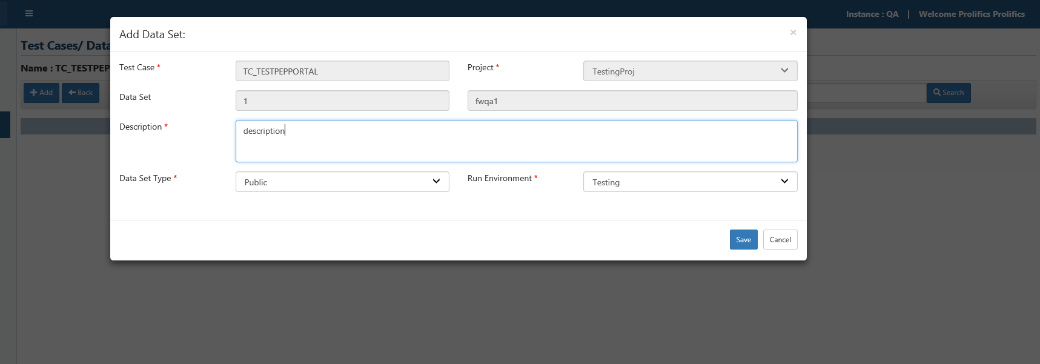

* Check **data set.**

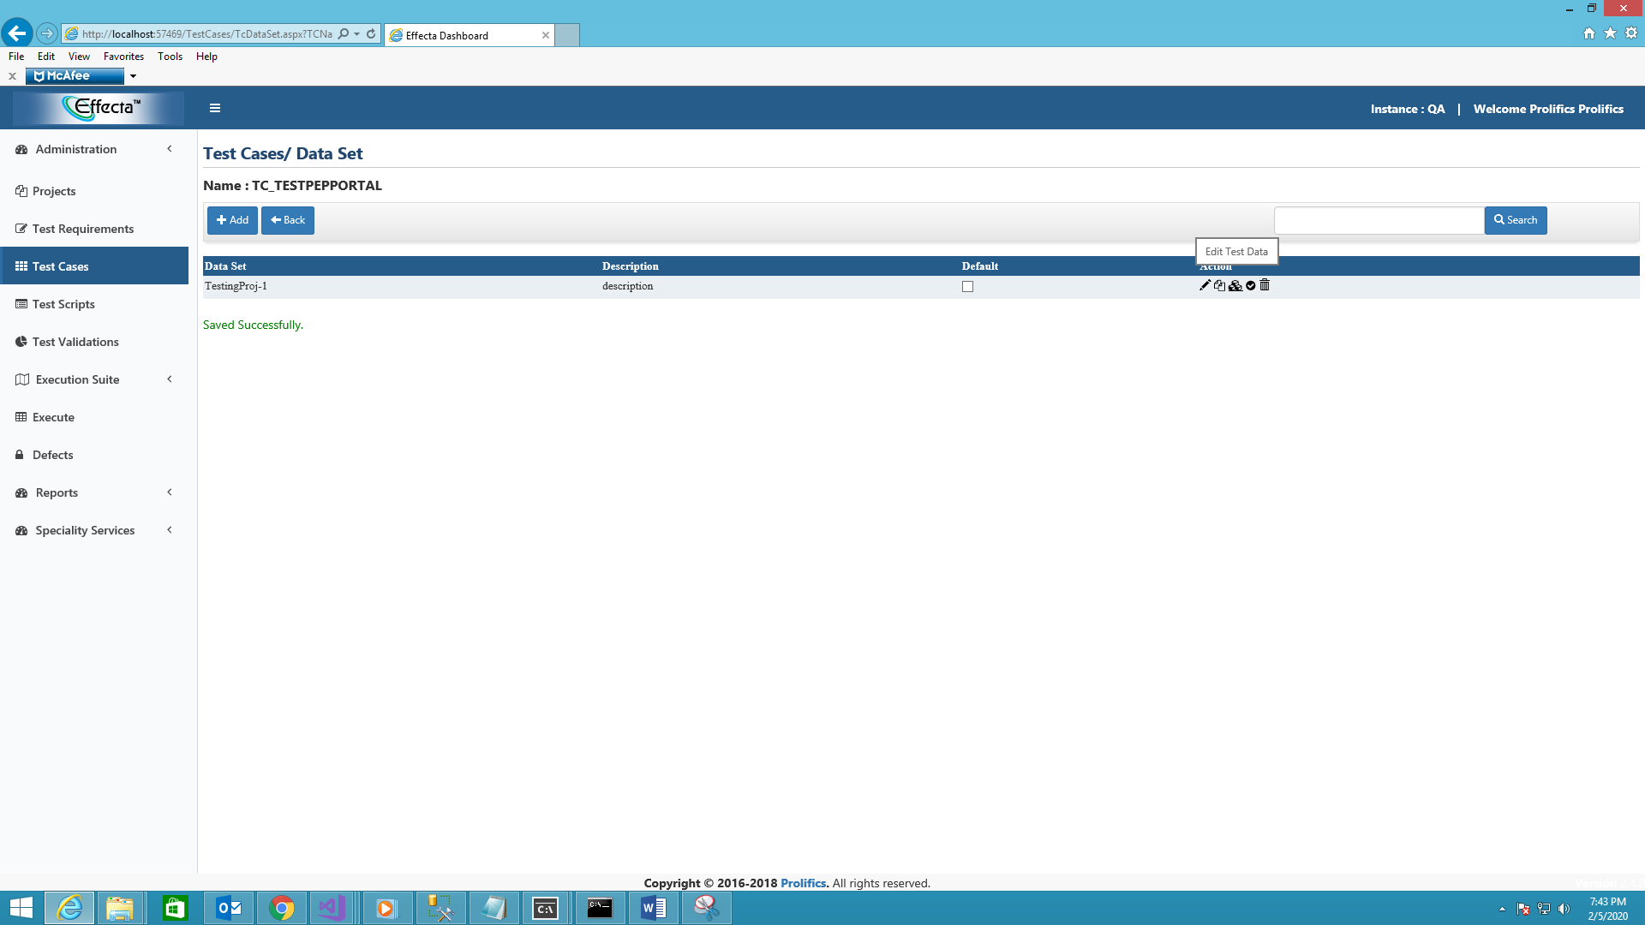

* Click on edit to check the test data.
* Click on header fields and click on expand all to see the data.
* There we can see the data we recorded and can be edited if wanted.

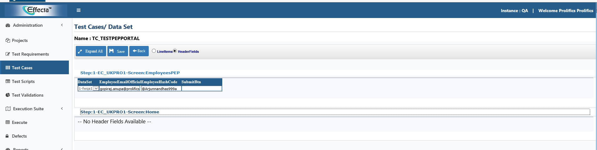

**Test run:**

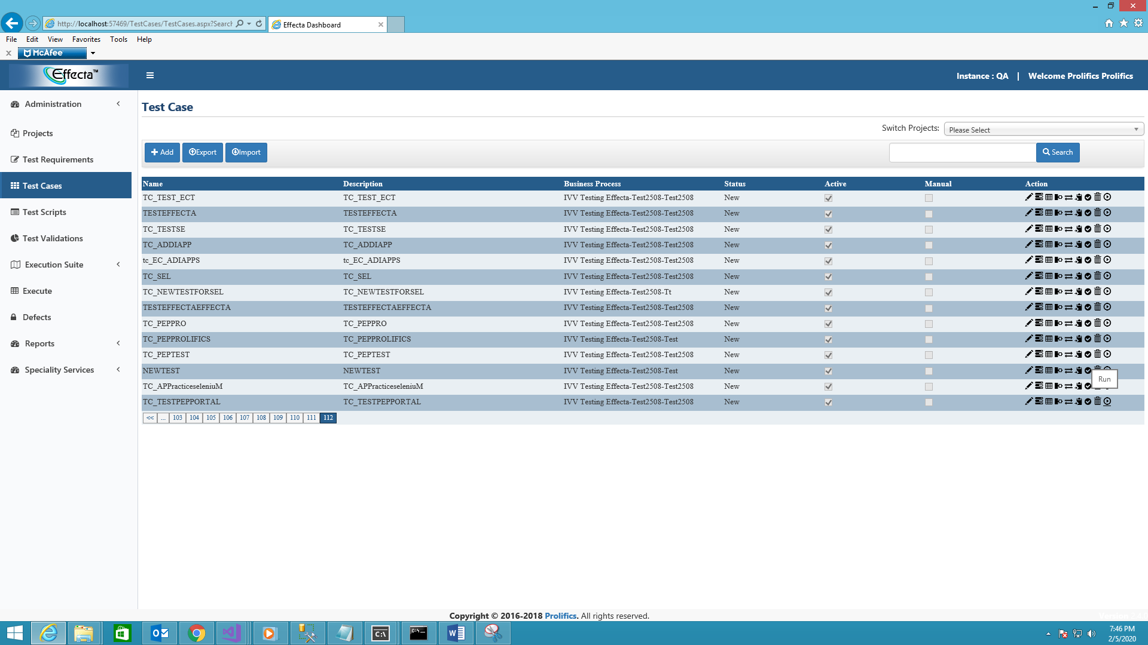

* Click on run.
* Then it loads execution window as follows.

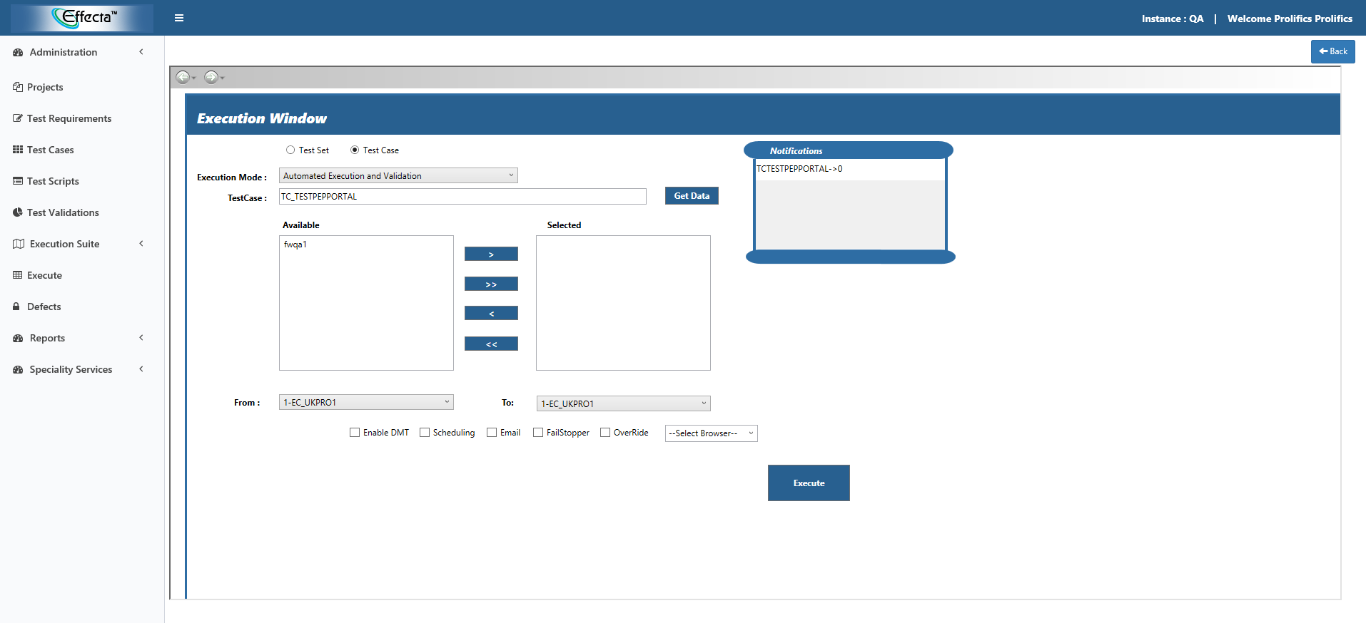

* We can see all the details regarding the test case.
* Select the available dataset.

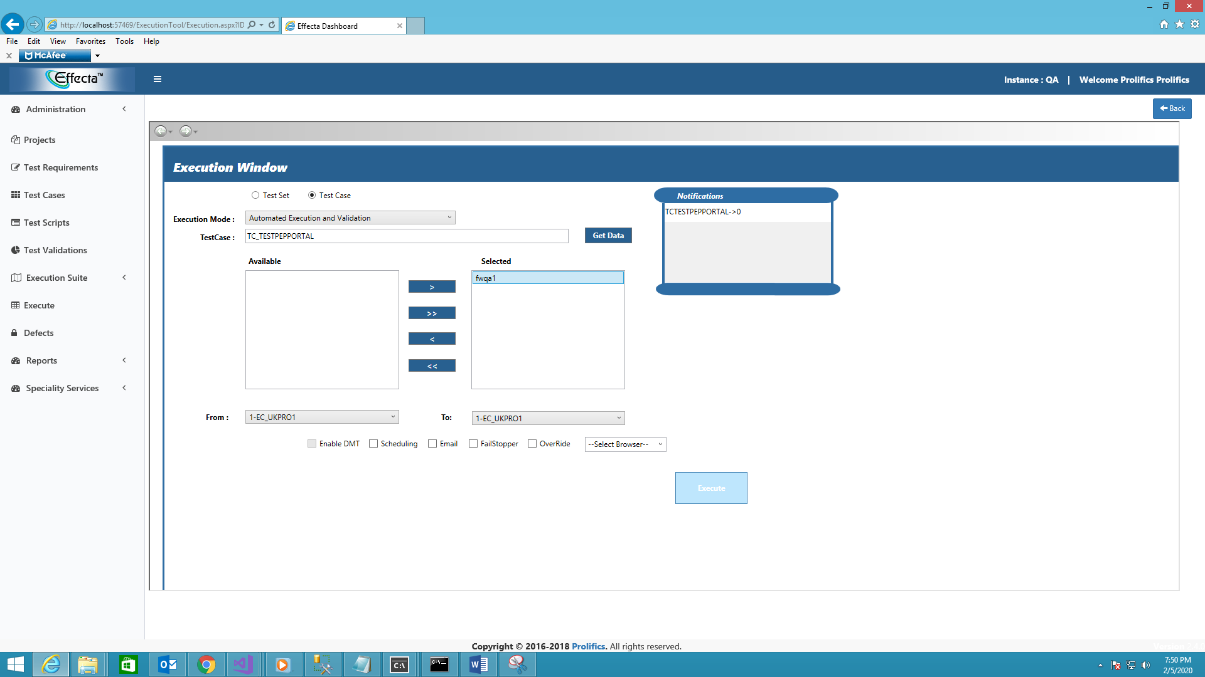

* Click on **execute**.
* On clicking execute

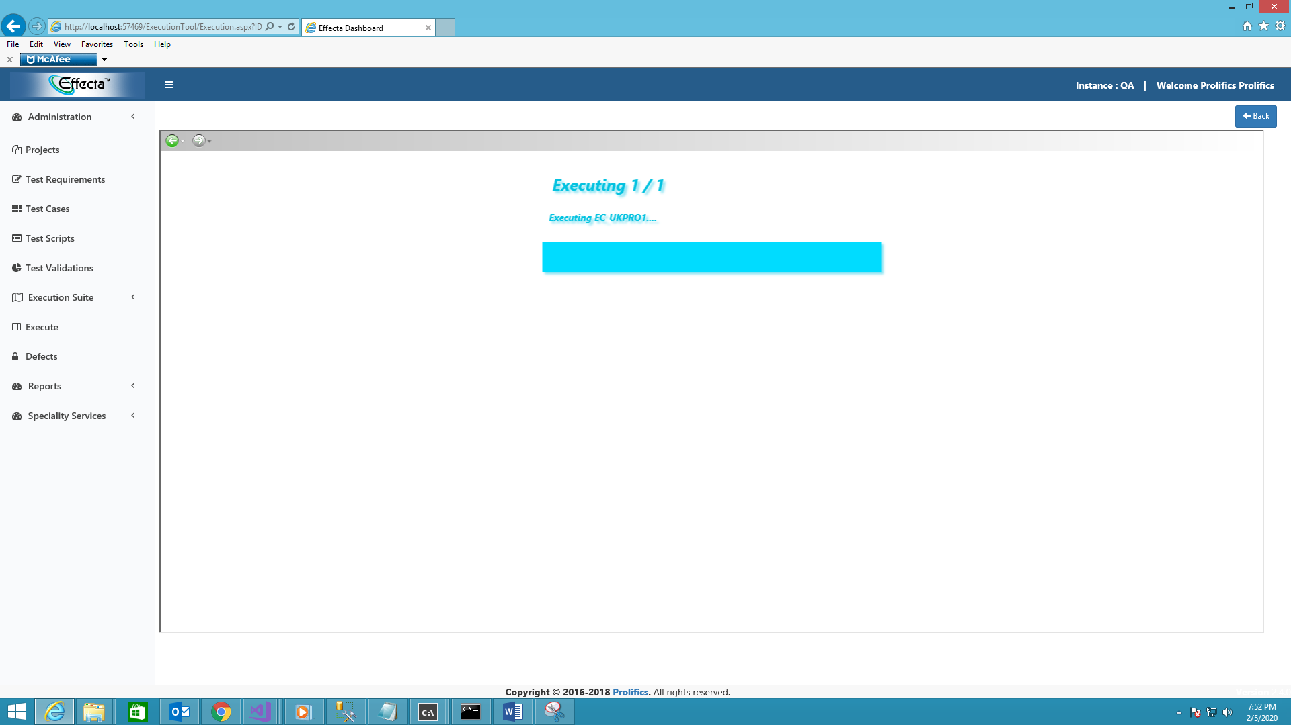

* When we click on generate script it compiles the pom file and main script files and stores in the following directory.

**C:\EffectaAutomationFramework\Selenium\prolifics\bin**

**Compiled POM files**

**C:\EffectaAutomationFramework\Selenium\prolifics\bin\pom\applicationame.**

**Ex: c:\EffectaAutomationFramework\Selenium\prolifics\bin\pom\peppro**

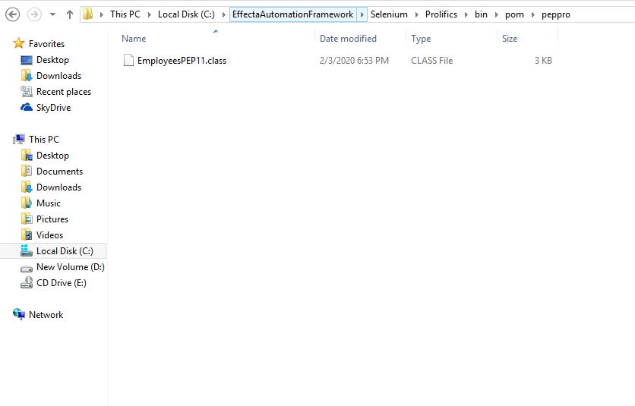

**Compiled main file**

**C:\EffectaAutomationFramework\Selenium\prolifics\bin\scripts**

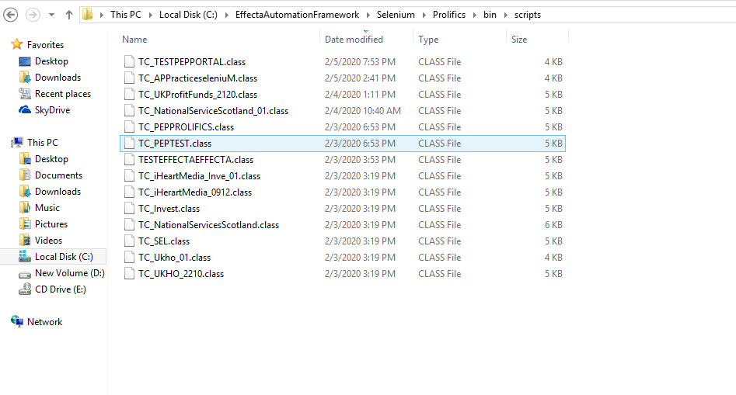

* On executing it displays the progress bar of execution details. And it automates and runs the test case.

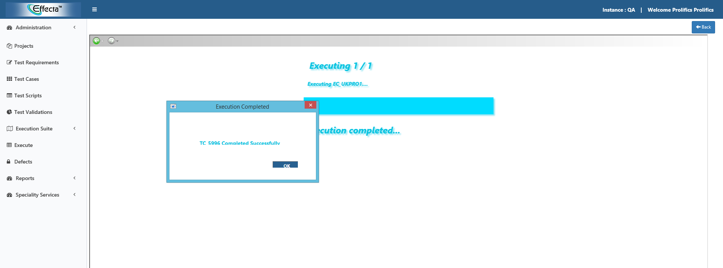

* Then it generates test report.